HOFFMANN AIRCRAFT

HOFFMANN AIRCRAFT CORP
P.0: Box No. 100
A-1214 Vienna
Austria
Phone (0 22 2/39 88 18 or 39 89 05

INSTRUCTIONS FOR CONTINUED
AIRWORTHINESS

H36 DIMONA

This Service and Maintenance Manual is for U.S. registered gliders.
(Type Certificate Data Sheet No.: ………………….EU)

Reg. No.:……………………… Ser. No.. …………………………….

Owner: ………………………………………………………………….
…………………………………………………………………..
…………………………………………………………………..

Published 15 Nov 1985

Approval of translation has been done by best knowledge and judgment. In any case the original text in German language is authoritative.

—1—
Hoffmann General
H 36 DIMONA

1. GENERAL:

Table of contents

Page
1. General ------------------------------------ 1
2. List of Revisions --------------------------- 2
3. System Description -------------------------- 3
4. Maintenance and Inspections --------- 23
5. Rigging ------------------------------------ 35
6. Weight and Balance --------------------------- 39
7 . Servicing ------------------------------------ 42
8. Repair ------------------------------------ 45
9. Table of consumables ------------------ 57
10. Airworthiness Limitations ------------------ 60

-2-
Hoffmann Revisions
H 36 Dimona

2. REVISIONS:

2. Revisions
.
Revision No | Affected Pages | Source | Date | Signature
-3-
Hoffmann Systems
H 36 Dimona Description

3. SYSTEMS DESCRIPTION:

Table of Contents

Paragraph page

3.1 FLIGHT CONTROLS ------------------ 4
3.2 AIRBRAKES & WHEEL-BRAKES --- 5
3.3 TRIM UNIT ------------------------------- 5
3.4 FUEL SYSTEM ---------------------- 10
3.5 POWER PLANT ---------------------- 12
3.6 ELECTRICAL SYSTEM ------------- 17
3.7 PITOT STATIC SYSTEM ------------- 21
-4-
Hoffmann Systems
H 36 Dimona Description

3.1 Flight Controls

All flight controls and engine controls are joined together by static ground cables. This is necessary, since a fibreglass aircraft has no common ground. When performing maintenance on or around these systems, care should be exercised that the grounding cables are not left unattached or broken.

a. Elevator control;
The elevator controls are mounted on a torque tube beneath the cockpit seats. Fore and aft movement on one stick is transferred thru the 35 mm dia. tube to the other stick. In the middle of the torque, on the lower side, a control horn is welded to provide an attaching point for the push-pull tube that is in the aft fuselage. Removal of the push-pull tube can be accomplished by removing the rudder, the attaching hardware on the tube and extracting it in a rearward movement. The aft end of the push-pull tube is connected to a bellcrank mounted on the vertical fin bulkhead. This bellcrank provides a 90* change of direction upwards. Another push-pull tube rises vertically and is connected on its’ top end to a double drive fork that connects automatically to an elevator drive lever. All push-pull tubes and bellcranks in the vertical fin assembly are accessible when the rudder is removed. The push-pull tube within the fuselage can be disconnected from it’s forward mounting bolt thru an access panel in the seat pan.

Travel stops for the elevator torque tube are located on the left side of the tube. The two screws with lock nuts are located on the traverse spar, left side, and can be adjusted within the cockpit without removing any structure or parts. Adjustment of elevator travel can be done by referring to Chapter 5, Rigging.

CAUTION
When adjusting or removing/installing elevator control, be sure to final check the security and attachment of the static ground cables!

b. Rudder Controls;
The connection from the rudder pedals to the rudder and steerable tail wheel is done by cables. The two cables lie within Teflon tubing aft to the rear fire wall, then are guided further aft by cable pulleys, to be connected at the rudder transient bellcrank. The cables are tensioned by springs affixed to each rudder pedal. From the transient bellcrank the two cables run aft to the rudder and are affixed to two turnbuckles at the bellcrank. The tension of these two cables is done thru turnbuckle adjustment.

CAUTION
The rudder control system is a closed loop system and can be affected by temperature changes. To prevent excessive cable tension, the cables (aft cables with turnbuckles) should be adjusted that from a straight line, they can be deflected two centimetres (2 cm).
The rudder stops are located on the lower rudder bearing fixture and are adjustable thru screws and stop nuts.
From the transient bellcrank two cables go to the steerable tail wheel. Two springs connect the cables to the tail wheel drive horn. Two turn-buckles permit spring tension to be adjusted and subsequent alignment of the tail wheel to rudder.
Adjustments of the two main cables can be made thru an access panel in the baggage compartment.

-5-
c. Aileron controls;
The two control sticks are connected to each other by two push-pull tubes beneath the seats. Their connecting point is beneath the middle console to a 90* bellcrank. From this bellcrank another push-pull tube travels aft to another 90* bellcrank affixed to the aft bulkhead. Two additional push-pull tubes are attached to the bellcrank and traverse the fuselage left and right to the butt rib. An automatic mating fixture (male/female) insures positive connection when the wings are attached. Within the wing, a long push-pull tube travels outboard to a 90* bellcrank, which is preset for differential aileron movement. To the 90* bellcrank is attached a shorter push-pull tube to the aileron drive horn.

The forward push-pull tubes in the fuselage are accessible thru access panels in the seat pan. The rear bellcrank is accessible by removing the fuel tank cover. The automatic mating fixture is accessible from the exterior of the aircraft. The outer wing bellcrank is accessible by removing a plexiglass inspection window in the outer lower wing.
The travel stops for the aileron system are located thru access panels in the seat pan and are adjustable by screws and jam nuts.

Play in the automatic mating fixture can be adjusted with set screws in the female side of the fixture.

3.2 AIRBRAKE DRIVE FIXTURE AND WHEEL BRAKES

The two airbrake levers are connected together beneath the seat by a torque tube. Control cables connect this tube to another torque tube mounted on the aft bulkhead. This torque tube extrudes left and right from the fuselage butt rib and connects automatically to a mating torque tube in the wing structure. Outboard in the wing four drive lugs are attached to the airbrake flap itself. The entire system is spring loaded in the “RETRACT” position and the brakes are retracted by releasing the lever in the cockpit.
The cable who connects the torque tubes are adjustable thru turnbuckles. Attached to the aft torque tube is a drive arm, which actuates the brake cylinder. From the master cylinder, a “T” fitting and tubing provide fluid pressure to each wheel brake assembly. The brake fluid reservoir is attached to the rear bulkhead and should be checked daily to ensure the fluid quantity is adequate.
The parking brake is incorporated into the master cylinder and is actuated by a push-pull Bowden cable.

3.3 TRIM UNIT

The trim for the elevator controls is accomplished thru two springs, attached to the elevator push-pull tube. The positioning of the trim lever located on the middle console is secured by a spring loaded locking teeth. Adjustment of the trim force can only be made by changing the trim springs. The trim force is adjusted at the factory, during manufacture. Correct trim forces can be measured when the trim lever is in the middle, neutral position. These forces are:

Pressure required, full forward: 30 N +5 N
full aft: 40 N + 5 N

-6-
Aileron and Elevator Controls in Fuselage

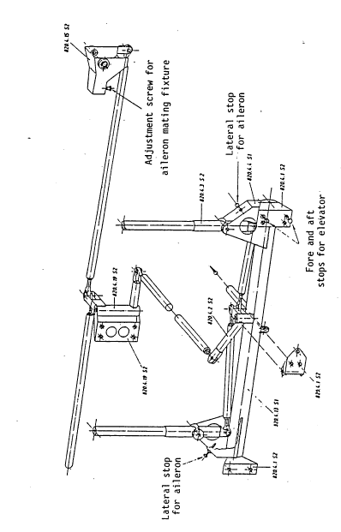

-7-
Rudder and Tail Wheel steering Controls

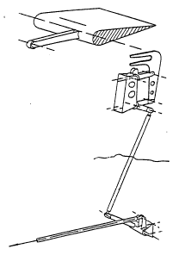

Elevator Controls in vertical Fin
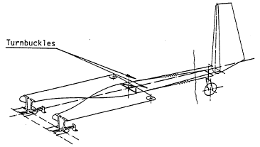

-8-
Airbrake Controls and Parking Brake
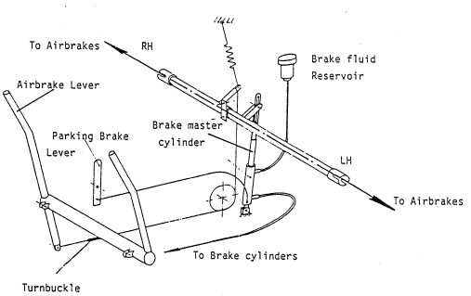

-9-
Aileron Controls in the Wing
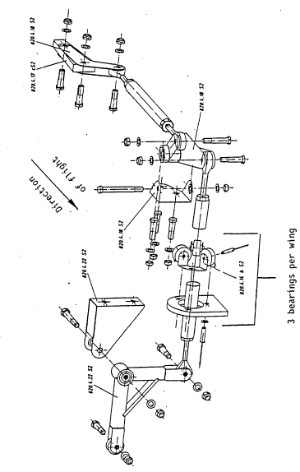
—10—
3.4 FUEL SYSTEM

The aircraft is equipped with a 80 1 fuel tank, constructed from fuel resistant Polyester fibreglass. The tank is installed between the main and rear bulkheads. The fuel tank cover, when secure, is the floor of the baggage compartment. The filler cap for the tank is outboard on the left side of the aircraft and is connected to the tank by a cast rubber neck assembly. The tank vent is a part of the fuel quantity sending unit and passes thru the fuselage lower skin, parallel to the drain fitting to the exterior of the aircraft. The fuel tank cap is NOT vented. The entire tank assembly is grounded by a copper net impregnated within the Polyester fabric. This grounding net is connected to the entire ground system in the aircraft with static grounding cables.

CAUTION

When working within the tank area, insure that the static grounding cables have been secured after the tank has been completed. Also check the static ground cable on the filler neck/flange assembly!

The bottom of the tank contains the fuel quantity sending unit, which is connected electrically to the fuel quantity gauge. Also, in the tank bottom is a “finger filter’ installed to hinder dirt and foreign matter. From the filter assembly a short hose is connected to the drain, which goes thru the fuselage floor to the exterior of the aircraft. In the normal “tail down” attitude this is the lowest part of the fuel system, and should water or dirt be in the fuel, it will be drained off at this point. From the fuel drain, a copper fuel line goes forward to the fuel shut-off valve, located in the middle console.

CAUTION

The fuel shut-off valve should only be closed in the event of an engine fire or during maintenance on the fuel system. The risk of attempting a take-off with a closed valve is too evident.

From the fuel shut-off valve the fuel line continues forward to the firewall and the installed fuel filter. The filter element is replaceable (Purolator No. GF—140/1, Limbach No. 17.20.180). The filter body is a part of the electrical fuel pump. From the electrical fuel pump a fire retardant fuel line goes to the engine-driven fuel pump and further to the two carburetors. In the engine-driven pump another fuel screen filter is installed.

To remove the fuel tank , the fuel tank cover and the cover of the brake fluid reservoir is first removed. Also the filler neck must be disconnected. Place a container under the aircraft and open the drain To accelerate the draining, a hand pump or electrical pump may be used thru the filler neck.

CAUTION

When de-fuelling always ensure the aircraft and pump are grounded, and a fire extinguisher is readily at hand!.

When the tank is empty, disconnect the wires to the fuel quantity indicator. Tilt the tank and disconnect the drain hose. Then tilt it upside down and lift from the aircraft. Hereby the canopy must be held half-closed by a second person.

Installation is a reverse of the removal procedures. Don’t forget the static ground wires.

-11-
Fuel System .Schematic

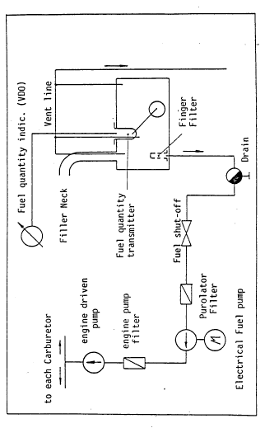
-12-
3.5 POWER PLANT

The engine in the DIMONA is a Limbach L 2000 EB 1.C. The engine is of opposed cylinder arrangement, 4 cycle, and delivers 80 hp rated power. The lubrication is wet sump. The engine is installed in the nose of the aircraft and is direct drive. The propeller is a Hoffmann HO-V 62R/Ll60T
or. L 160 BT . The propeller has three pitch positions and is mechanically actuated.
The engine is installed within the fuselage on traverse members, fore and aft. On each corner of the traverse assemblies are “Silent Blocks” which serve as shock mounts to negate engine vibration. The “Silent Blocks” are installed at a 45EoB angle to permit optimum dampening. Within the dampener blocks are steel lugs to prevent excessive movement of the power plant assembly. These lugs also act as restrainers, should the rubber mount be damaged. The fuselage structure is so designed, that the stringers, on which the dampeners are attached, carry the load thru the entire fuselage. This type of engine installation has several distinct advantages.

a. Engine movement is restricted
b. Vibration and noise in the cockpit area is reduced
c. In the event that an emergency landing is performed, the fuselage structure absorbs the impact loading and not the engine or engine mount.

The fireproof bulkheads in the engine compartment are providing safety for the cockpit in the event of fire and protect the forward structure as well.

1. Engine removal;

The engine must be removed for overhaul or repair.

a. Loosen and remove the four screws on the engine cowling, remove cowling.
b. Remove lower air vent grill.
c. Remove Positive (+) cable from battery and the following electrical cables with their respective cable numbers: Starter cable Nr.2 Ground cable Nr. 3, Cylinder head temperature cable Nr. 6, Oil temperature Nr. 7, Ignition Ground Nr. 9, Oil Pressure and Oil Pressure Warning Nr. 10 and 11, Voltage Regulator Nr. 15.
d. Fuel shut-off valve close. Then disconnect fuel line from the exit side of the electrical fuel pump.
e. Air Filter on right carburetor, remove.
f. Heater hose on heater distribution box, remove.
g. Bowden cables on choke and heater valve, loosen (Bug nut fitting).
h. Throttle cable on combining throttle rod, disconnect.
i. Tachometer cable, disconnect.
j. Propeller pitch change cable, disconnect.
k. Turnbuckles on V-form tensioner beneath the engine, loosen.
1. Four bolts between Silent Blocks and Stringers, remove.
m. Engine assembly, with exhaust, accessories and Propeller can now be lifted from the fuselage.

-13-
2. Engine Installation

The engine installation is a reverse of steps a. thru m.

NOTE

When the engine is reinstalled, the engine will hang slightly left (20). After the engine is replaced in the fuselage, the two turnbuckles should be pulled up, until they are tight. All bolts are either safetied with wire or Nylon insert nuts. Engine compartment Nylon nuts should be only used once! Attention should be paid to proper safetied bolts or nuts!

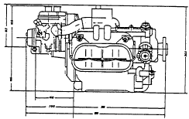

-14-
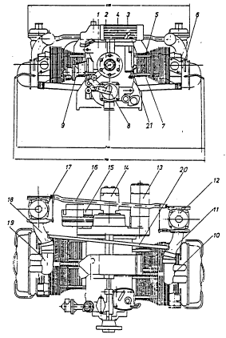

Engine Component Description

1. Crankcase 11. Induction Manifold (L/H)
2. Propeller Flange 12. Carburetor (L/H)
3. Crankcase Breather 13. Starter
4. Oil Cooler 14. Magneto
5. Cylinder 15. Generator
6. Cylinder Head 16. Carburetor Actuating Shaft
7. Oil Filler neck 17. Carburetor (R/H)
8. Oil Pump with Angle Drive 18. Induction Manifold (R/H)
9. Engine Driven Fuel Pump 19. Induction Pipe (R/H)
10. Induction Pipe (L/H) 20. Manifold Equalizer Hose
21. Oil Dip Stick

The Carburetors installed on the Limbach engine are Stromberg Zenith 150 CD-3. These carburetors are called equal or constant speed carburetors. The pre-positioning of the carburetor flapper valve regulate the amount of suction (intake) being produced by the engine thru the intake manifold. To balance this suction the piston in the carburetor body ascends or descends (depending on flapper valve position) within the under pressure chamber. This piston (membrane ) movement moves the fuel needle with it. The fuel/air mixture is therefore in balance, hence the term “equal pressure” carburetors.

-15-
a. Idle System;
The carburetor does not have a separate idle system. When the piston (Membrane) is in the idle position, i.e. fully closed, the fuel needle provides sufficient by-pass fuel to retain the desired idle speed.

b. Main System;
When the engine is running the following events take place when the throttle is opened. As the flapper valve opens, the outside pressure (atmospheric) is greater than the internal pressure (manifold). Thus the piston assembly in the carburetor chamber, due to pressure in the dome rises. This movement increases fuel flow thru the tapered fuel needle, the engine accelerates until the pressures atmospheric/manifold are equal. The closing of the throttle is in effect a reverse of acceleration. At all times the airflow thru the carburetor throat is constant, hence the term “constant speed or equal pressure

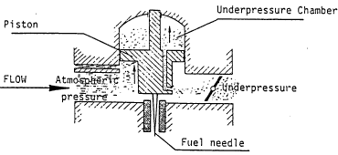

c. Acceleration System;
A rapid opening of the flapper valve would cause a excessive mixture. To prevent this, the piston is contained in an oil bath, creating a hydraulic dampening action. The oil viscosity is an important function of the dampening action and only “ZENITH” original oil should be used.

d. The carburetor membrane should be inspected every 100 hours (see inspections). To perform this inspection it is not necessary to remove or adjust the carburetor. Perform the following steps to accomplish the inspection:

1. Screw cap, No. 64, with piston rod and piston, Remove.
2. Spring 63, Remove
3. For mounting screws 4, remove
4. Pressure Piston 9, Membrane 8, extract, CAREFULLY! Pay attention not to bend the needle!
5. Check the membrane for cracks or tears.
6. Should the membrane be defective, remove the screws 6 and separate the membrane holder 7 from the membrane. Replace the membrane with a new one.
7. Re-assembly is a reverse of steps 1-5. Prior to closing the screw cap, fill the cavity with ZENITH oil to within 10 mm of the top.
-16-
Carburetor Stromberg Zenith 150 CD-3

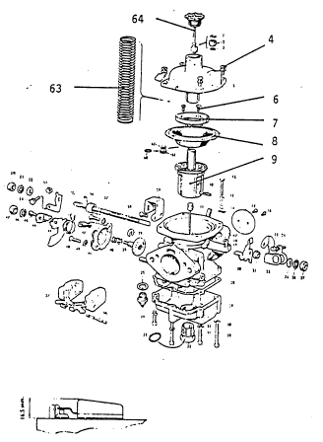

64 Screw Cap with piston rod and piston
63 Spring
4 Screws, retaining
9 Pressure Piston
8 Membrane
6 Screws, Retaining
7 Membrane Holder

e. Replacing Float Chamber Needle, and adjusting Float level.
1. Remove the carburetor from the engine.

a. Remove float chamber cover, lift out float
b. Immerse Float in hot water to check for buoyancy. If not water tight, replace float.
c. Float needle can be removed by un-screwing, and a new needle inserted.
d. Proper Float level can be measured from the float chamber (without cover). From the top of the float chamber to the tapered top of the float should be 16.5 mm. The two floats should be the same height. If not carefully bend the float tabs to parallel the floats.
-17-
2. Testing newly installed float and/or needle.

a. Reinstall Carburetor, install air-filter. Set idle speed by idle set screw 24 until 600-700 RPM is obtained with a warm engine.

3. Engine Inspection after sudden stoppage.

a. Remove engine. Engine should be returned to the manufacturer for inspection. The checking of the propeller flange does not indicate an torque warping within the engine or damage to the engine case studs.

4. Spare Parts; Spare parts for the Limbach Engine should be obtained either directly from the Limbach Co. or from Hoffmann Flugzeugbau.

3.6 Electrical System:

In the following description, all numbers in brackets can be equated to the similar numbers on the wiring diagram. The current producing side of the system is a Lead-Acid Battery and an Engine driven Generator. Two battery types, 16 or 28 Ampere hour Capacity can be installed. The battery had a central venting system, to provide overboard venting of corrosive gases. The Generator (7) can be of two types, 22 or 40 Ampere hour units. The both Generators are AC current Generators and the current is converted to DC by DC Diodes. The Voltage Regulator (8) is a transistor Regulator. To separate the current from the system an main switch (2) is installed. With the exception of the Starter, all electrical components are backed up with a Fuse or Circuit Breaker. The E-T-A Circuit Breakers operate on the over-temp principal. The Main Fuse (4), when switched off, breaks the circuit between the Buss Bar and the Battery. Generator Voltage (7) goes thru a 25 Ampere Fuse (5) to Buss. The Voltage Regulator has it’s own Fuse (10). The electrical circuit is designed to provide the Voltage Regulator current when switched on. Normally in the Glider mode undesired current loss would occur, and possibly deaden the Battery. However, when the engine is shut down and the oil pressure sinks below 0.5 bar, the warning contact on the oil pressure switch (12) and the Current Relay (9) closes. Thus the current to the Voltage Regulator is switched off and no current loss occurs.

NOTE
When trouble shooting the system for electrical faults, remember that current is switched off to the Voltage Regulator when the engine is not running!

To provide a cockpit check instrument, a Voltmeter (11) is installed in lieu of an Ammeter. This instrument offers a more precise evaluation of current being produced. With the engine NOT RUNNING it should show 12-l3VDC. After the engine is started, it should or can climb to l4VDC. When the engine has warmed up it should remain at l4VDC. Should this not take place then the Battery has no charge or a fault within the charging system exists.

If the voltage shown is to high, then the problem lies within the Voltage Regulator and severe damage to the battery may occur. Engine performance instruments are installed to monitor the powerplant system. They are: Electric Oil Pressure (15/17), Electric Oil temperature (16/18) Electric fuel Quantity Gauge (14/13) and Cylinder-head Temperature Indicator (24/25/26/27). The technical function of the above is basically the same. The transmitters produce a certain resistance, and the indicators provide a readout of the resistance value. The only instrument not connected to the wiring circuit is the Cylinder-head Temperature unit. Using a thermocouple, it produces its own current and resistance. The unit is very sensitive and loose connectors or chaffed wiring can lead to immediate erroneous readings.

-18-
NOTE
Should the Thermocouple wiring be damaged, it cannot be spliced. It must be replaced, to retain its’ original resistance value!
To increase fuel flow, especially for starting the engine, an electrical fuel pump is installed (19). The pump is an electromagnetic pump with membrane. The pump is activated by a separate switch.
The Limbach engine is equipped with either Slick (4230) or Bendix (54RN21) Magnetos. The magneto is rendered inactive by shorting it to ground. It is very important to insure a good connection between Magneto and switch and that the switch is properly grounded.

CAUTION
When the grounding cable is removed from the magneto or switch, the magneto is HOT and the engine can fire if the prop is turned. Never leave a HOT magneto un-attended!

The wiring bundles in the DIMONA are arranged to prevent chafing or abrasive contact. Guide tubes, PVC tubes, clamps and ty-raps are used for this. By repairs or modifications, care must be taken not to expose wire bundles to possible damage. All connectors are crimp type. A few exceptions are soldered connections, made by the manufacturer. An isolated connector has more strength than the wire itself, when the proper crimping tools are used. Do not attempt to repair a broken wire when the proper crimping tools are not available!

The circuit breakers and Fuses operate on a Thermal Overload. They have an absorption capacity of 200 Amperes, then they switch automatically to OFF. They cannot be reset until the defective system cools below the 200 Amp. heat range. Do not continue to reset a popped circuit breaker. The circuit breaker is telling you something-s wrong!

The installed fuses have the same Ampere rating as the circuit breakers.
The fuse board is connected to the circuits by approved connectors. In the right instrument panel are the Main fuse, 25 Amp., Generator fuse 25 Amp., Engine Instrument fuses and Voltage Regulator fuse.

Switches installed in the DIMONA are single pole, single, throw type.
They have the capacity of 20 Amp., 28 VDC. The ignition switch is either JAN-ST 40A or MS 35058-22. These two switches cannot be replaced by switches with another specification, due to grounding values!

Antennas are installed at the factory. VOR antenna is behind the rear fuselage bulkhead, ADF and OME/Transponder antennas under the fuselage between Firewall bulkhead and Main spar bulkhead.

The Radio loudspeaker is installed in the canted console between the seats. When installing a speaker, the Rovings on this console should not be damaged or modified! In the canted console is installed a tube, assigned for wires.

-19-

The following electrical components and respective part numbers are installed as standard equipment on the H 36 DIMONA.

Nomenclature Part Number
1. Battery with central venting 51612 or 52815
2. Battery main switch, Bosch 0 341 001 001
3. Starter, Fiat, 12 Volt, 130 Amp. npn
4. Main fuses, 25 Amp., E-T-A 2-5700-KlO-DD-25A
5. Generator fuse, E-T-A 2-5700-Kl O-DD-25A
6. Starter Button, Bosch 0 343 003 001
7. Generator, Ducellier, 14 VDC/22 Amp. or 7532
Generator, Motorola, 14 VOC/40 Amp. 9 AL 2696 G
8. Regulator, Electrical Current, Wehrle or DU 506/ l4VDC
Regulator, Electrical Current, Motorola (Transistor) 9 RH 7013
9. Relay, Bosch, 12 VDC 0 332 204 150
10. Circuit Breaker, E-T-A- 2-5700-Kl 0-1 0056A
Circuit Breaker, E-T-A 2-5700-Kl 0-1003 .5A
11. Voltmeter, Motometer (or VDO) 685.002.1002
12. Oil Pressure Switch (component of oil press. transmitter) npn
13. Fuel Quantity Transmitter (in Tank), Motometer or VDO 608 001 1055
14. Fuel Quantity Indicator, Motometer (or VDO) 609 003 1012
15. Oil Pressure Indicator, Motometer (or VDO) 644 001 1002
16. Oil Temperature Indicator, Motometer (or VDO) 641 011 1010
17. Oil Pressure Transmitter, VDO 360 081 030 002
18. Oil Temperature Transmitter, Motometer (or VDO) 642 0091021
19. Fuel Pump, Electric, Hardi E 65
20. Circuit Breaker, E-T-A, 3.5 or 6 Amp. Same as 10
21. Switch, APR 20-631 n/2 20 Amp., 28V

Wiring Diagram

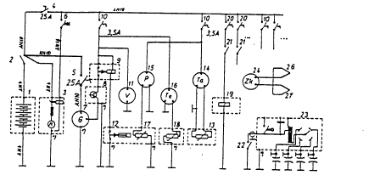
*) Grounded on case by installation Unmarked wires are AN 16

22. Switch, Ignition, JAN Type ST 40 or MS 350058-22
23. Magneto, Slick or Bendix Refer to Limbach
24. Cylinder-head Temperature Indicator, Westach 2A1-2
25. Equalizing Thermo Element (included with Westach)
26. Element, Heat Transfer (for Spark plug) Included with 24
-20-
Electrical Cable Marking

1. Positive terminal battery to Main Switch
2. Main Switch to Starter
3. -Ground C-) Engine Mount to Negative Pole Battery C-)
4. Ground Engine Mount to Firewall (Regulator)
5. Fuel Quantity Transmitter
6. Cylinder Head Temperature Transmitter
7. Oil Temperature Transmitter
8. Starter Relay
9. Ignition Ground Wire
10. Oil Pressure Transmitter
11. Oil Pressure Warning Contact
12. Electric Fuel Pump
13. Generator Regulator, Current
14. Generator Regulator to Relay
15. Regulator to Generator, Field
16. Generator to Generator Fuse, 25 Amp.
17. Main Switch to Main Fuse, 25 Amp.
18. Radio Speaker
19. Transmitting Button(s), Pilot’s Control Stick
20. Position Lights (includes positions 20 thru 24)
25. Anti Collision Light

Wire Sizes

1 to 3: AN 4 Wire, 22 mm²
5, 7, 8, 10 to 15, 20 to 25: AN 16 Wire, 1.2 mm²
4, 16, 17: AN 10 Wire, 5.3 mm²

Permitted Loading on AN 16 Wire:

Wire Length in m | 30 | 15 | 6 | 3
Current (Amp.) | 1 | 2 | 5 | 10

Anti Collision Light is usually installed on the upper side of the fuselage or of the Horizontal fin. Care should be used not to install it in the immediate vicinity of the VOR antenna. The antenna should not be installed on the vertical fin, since a cable disconnect will be necessary each time the aircraft is disassembled. The light is switched thru a toggle switch installed on the switch panel.

Position lights are switched thru toggle switch (fused) on the switch panel. If position lights are not installed at the factory, information concerning the installation and the necessary wiring and routing are available from Hoffmann Flugzeugbau.

Electrical circuit loading:
1. Current for Engine instruments 0.3 A
2. Current for Voltage Regulator max. 1.5 A
3. Electric Boost Pump, max. 1.0 A
4. Starter, max. 130.0 A
5. Lighting (Whelen Strobe) 1.7 A
6. Position Lights, max. 5.0 A

-21-

When ordering Avionics, pay attention to the current requirements. The Generator delivers 22 Amp. and the sum of all required current above, less Starter is 9.1 Amp. To maintain a safety factor, no more than 17 Amp. are available to compensate for Voltage drop and current surges.

Most Avionics today will not consume the available current, however, the Transmitter of a VHF Radio may. It is highly recommended that a reliable Avionics shop be consulted when installing Avionics, after the Aircraft has been delivered from the Factory. The smaller battery is rated for 10 hours gliding with one radio receiver on and an electric Variometer operating. If flight planning is such that position lights, Anti Collision Light or other avionics are to be used, then the larger battery must be installed.

General rules for working on electrical components:

Turn the main switch off and disconnect the Negative Battery cable. With this done, a short circuit is impossible. Repair procedures set forth in FAA 43.13-la are to be followed. Approved material is to be used (AN, MS or NAS). Soldered joints are not acceptable. Wire must have the original material area The maximum Voltage loss within the system is 0.5 VDC. Consequently when the Battery is fully charged, the lowest reading in the system should be 13.5 VDC.

CAUTION

Before removing or disconnecting the battery, insulate the rudder cable. If this is not done, a short circuit with the rudder cable may happen

Pitot Static System:

By removing the glare shield, covering the instrument panel, access can be gained to all flight instruments. Instrument lines and hoses should be checked for security and damage. Installed within the vertical fin are the pitot and compensation tubes. Under no circumstances should they be blown into. Severe instrument damage will result! To check the pitot system for function, place a short length of surgical tubing (18”) over the pitot tube. Tie the other end shut. Slowly roll the tubing up toward the pitot tube. The air trapped in the tube will compress and produce an effective reading on the airspeed indicator.

-22-

The following schematic illustrates the pitot static system as installed in the DIMONA.

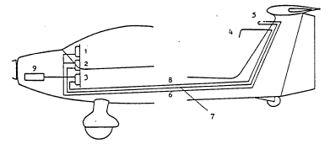

1. Altimeter 6. Static port (blue)
2. Air speed 7. Pressure (green)
3. Rate of Climb and Decent 8. Compensation Tube (red)
4. Compensation nozzle 9. Equalizing Bottle (0.45 1)
5. Pitot / Static Tube
-23-
Hoffmann Maintenance and
H 36 DIMONA Inspections

4. MAINTENANCE & INSPECTIONS

Table of Contents

Paragraph Page

4.1 General --------------------------------------------- - 24
4.2 Inspection checklists for 50/100/500 hours ---------- 25
4.3 Inspection Criteria ------------------------------------- 30
4.4 Test Flights ---------------------------------------------- 33
4.5 Special Inspections ------------------------------------- 34
—24—
Hoffmann Maintenance and
H 36 DIMONA Inspections

4.1 GENERAL

The performance of Inspections on the H 36 DIMONA is easily done. The aircraft requires no special tools or fixtures to complete all items on the checklist. Our experience is that one mechanic can perform the 100 hr inspection in less than one day, providing the aircraft has been maintained to standards. The use of two persons can expedite the work and two will be needed for a few minutes to pull and fold the wings, should that be necessary.

The outer surface of the DIMONA has been sprayed with a two component paint to provide a lasting finish. The only care needed to protect the gloss finish is periodic washing with warm water and a mild detergent. We suggest that once a year (more often, if the aircraft is not fully hangared) a good automotive wax be applied and hand polished. This not only protects the finish, but improves the aerodynamic qualities of the aircraft, especially the wing upper surfaces.

Extra copies of the DIMONA check list should be made from the blank master copy that is sent with the aircraft documents package. The reduced size copy in the handbook can be used for reference. We suggest, that accurate records, especially the inspection and test flight sheets, so that work performed or faults discovered, can be evaluated. It will also provide a perspective buyer an opportunity to review your efforts in maintaining your aircraft and will always influence a sale.

A short comment on TBO (Time between overhauls): You will probably use the DIMONA in its dual roles, one as a glider and one as powered aircraft. Don-t forget to remember that engine time may not be the same as airframe time. The hourmeter in the cockpit will record engine time only. The pilot in command should determine the hours flown in the glider mode.
-25-
4.2 INSPECTION CHECKLIST FOR 50-100-500 HOUR INSPECTIONS:  A. Powerplant:  1. Start engine and run until temperatures are in green range. Shut down engine.  2. Remove engine outlet air grill and clean  3. Inspect grill and engine cowling for security and damage.  4. Remove wiring from spark plug tips and remove spark plugs  5. Perform compression test on all four cylinders (differential pressure check).  Nr. 1: …………. Nr. 2 ……………. Nr. 3: …………. Nr. 4: …………..  6. Remove sump plug and drain engine oil  7. Check oil screen for metal particles, wash oil screen in solvent bath and dry.  8. Oil temperature, oil pressure fittings, check for security and oil seepage  9. clean oil cooler and check for security and leaks.  10. Replace sump plug, re-fill engine with 2,5 ltr. oil  11. Clean engine (solvent or degreaser)  12. Check valve clearance (cold), replace cylinder head valve gaskets.  13. Remove air filter and clean by compressed air. Blow  air from inner surface to outer surface.  14. Replace air filter element with new element  15. Check fuel lines from carburetor, fuel pump and fuel  filter for security and damage.  16. Replace fuel filter element with new element  17. Replace float needle in carburetor  18. Clean filter in engine driven fuel pump  19. Drain fuel, remove finger filter and check for  dirt and condition. Look also Pos. 11 and 14 (Fuselage)  20. Check carburetor membranes  21. Check flapper valve play in carburetor throat.  If play exceeds 0.8 mm. repair by bushing or replace.  22. Check oil level in carburetor dome. Add original  “Zenith lube oil” if necessary.  23. Check carburetor, choke, heater and air bowden flex  cables for ease of movement. Lubricate if necessary  with light oil.  24. Check engine mounting bolts and Silent blocks for  security, safety and damage.  25. Check V-wire brace beneath engine for security. If  cables are loose, re-tighten.  26. Check Generator belt for security and condition.  Replaced frayed belt.  27. Check ignition timing (Refer to Limbach handbook)  28. Inspect magneto points. Replace if worn.  29. Check ignition harness for security, abrasion and  porosity. Replace cracked or damaged harness.  30. Electrical and connectors md. battery, check for  security, damage and corrosion.  31. Clean spark plugs and reset gap (0.4 mm). Replace  plugs after 200 Engine hours.  32. Check exhaust system for blow by, cracks and security.  33. Remove heater shroud and check for cracks, hot spots,  corrosion and damage.  34. Check engine case for oil seepage or cracks | 50 | 100 | 500
 | 0  0  0  0  0  0  0  0  0  0  0  0  0  0  0  0  0  0  0  0  0 | 0  0  0  0  0  0  0  0  0  0  0  0  0  0  0  0  0  0  0  0  0  0  0  0  0  0  0  0 | 0  0  0  0  0  0  0  0  0  0  0  0  0  0  0  0  0  0  0  0  0  0  0  0  0  0  0  0  0  0  0  0  0
  0
-26-

35. Check engine breather for blockage. If blocked, remove and clean.  36. Check cylinder air baffles for security and condition.  37. Check firewall for security and, where bulkhead  fittings pass thru, for sealing.  38. Check combining hose between carburetors for security and porosity.  39. Check battery for damage and security. Check  water/acid level. If low add distilled water.  B. Propeller:  1. Remove propeller spinner and check for condition.  2. Inspect the four thrust rods for condition,  grease rods and mating surface of plate with  Calypsol H 442 or equivalent grease.  3. Check propeller blades for installation and  security. Check function of pitch change system.  4. Check pitch stops for ease of function.  5. Check pitch change lever for security and function.  6. Check prop flange bolts with torque wrench. Prop  flange nuts should not turn with 45 Nm force.  7. Check propeller blade cuff for cracks. If cracks  are longer than 0.1 mm wide, notify manufacturer.  8. Check propeller blade paint and leading edge  shield for cracks 90* to blade length. If such  cracks exist, notify manufacturer.  9. Check leading edge shield for 900 cracks,  security and condition. Such damage, including  de-bonding or separation should be reported  immediately to manufacturer. | 50 | 100 | 500
 | 0  0  0  0  0  0  0  0  0  0  0  0  0  0 | 0  0  0  0  0  0  0  0  0  0  0  0  0  0 | 0  0  0  0  0  0  0  0  0  0  0  0  0  0
-27-

C. Cockpit area:  1. Check cockpit canopy for security and damage,  frame and latching unit for function.  2. Check seat belts for security and damage. Check  mounting/attaching bolts for security.  3. Check trim unit for damage and function.  4. Check rudder pedals for security, free movement  and function. should the occasion arise, lubricate.  5. Check control stick for freedom of movement and  function. Check 0-position in reference to ailerons.  6. Check airbrake lever for function and positioning.  Check wheel brakes for function when airbrake lever is in full up.  7. Check that installed replaceable fuses have the proper Amp. rating.  8. Check instrument markings for legibility.  9. Check all control knobs and handles for security and proper color coding.  l0. Check all switches, circuit breakers, instruments  and fuel shut-off valve for security and function.  ll. Check seat adjustment unit for condition and security.  12. Check safety on main bolts for security  13. Check main bolts for smoothness of operation.  Should bolts bind, check for burrs and lubricate. | 50 | 100 | 500
 | 0  0  0  0  0  0  0  0  0  0  0  0  0 | 0  0  0  0  0  0  0  0  0  0  0  0  0 | 0  0  0  0  0  0  0  0  0  0  0  0  0

-28—

D. Fuselage:  1. Check exterior skin of aircraft for security and damage.  2. Check ailerons for function and security.  3. Check aileron outboard controls (thru plastic  window) for function and security.  4. Check airbrakes for proper seat and safeties.  5. Remove horizontal stabilizer assy. and check’  mounting fittings for security and corrosion.  Check rod end bearings for cracks  6. Cheek elevator attachments for function and security  7. Check elevator drive for function, security and corrosion.  8. Check rudder mounts and cables for function and security.  9. Check tail wheel for function and security.  Check tire for tread wear and proper inflation.  l0. Remove rudder and lubricate hinge bushings.  Drain static pitot system from water.  ll. Remove baggage compartment floor. Check:  a. Rudder cables, rudder cable drive  b. Aileron bellcranks  c. Airbrake drive.  Check all above for function, security and corrosion.  12. Remove baggage compartment panel on aft bulkhead.  inspect the following:  a. Control cables  b. Turnbuckles and springs in tail wheel steering  Check all above for function, security and corrosion.  13. Check brake fluid reservoir for security and proper fluid level.  14. Check fuel lines and tank assy. for security and leaks.  15. Check static ground wires and outboard installed  electrical units, ie. lights for function and security.  16. Check pitot static, TEK nozzle and antenna units  for condition and security.  17. Check moisture drain holes and vents for stoppages  18. Check placards and markings.  19. Remove wings and check airbrake drive-lubricate  20. Check aileron drive in butt rib-wing/fuselage for function-  lubricate  21. Lubricate remaining points in lube diagram.  22. Re-install wings. | 50 | 100 | 500
 | 0  0  0  0  0  0  0  0  0  0  0  0  0  0  0  0  0 | 0  0  0  0  0  0  0  0  0  0  0  0  0  0  0  0  0  0  0  0  0 | 0  0  0  0  0  0  0  0  0  0  0  0  0  0  0 0  0  0  0  0  0  0

-29-
Hoffmann Maintenance and
H 36 DIMONA Inspections

E. Landing Gear  1. Clean landing gear  2. Check landing gear for cracks, un-bonding or deformity  3. Check landing gear mounting bracket for proper seating  4. Check brake pucks for condition and wear.  5. Check tires for condition, check tire tread for  cuts, abrasion and porosity.  6. Check tire pressure.  7. Check wheels, especially rim bead for cracks or damage  8. Check brake lines for security and condition  F. General  1. Check manufacturers service bulletins for compliance as required.  2. Check ad notes for compliance.  3. Perform test flight for completion of inspection. | 50 | 100 | 500
 | 0  0  0  0  0  0  0  0  0  0  0 | 0  0  0  0  0  0  0  0  0  0  0 | 0  0  0  0  0  0  0  0  0  0  0

NOTES

Motorglider H 36, Reg. Nr. ____________ has had a 50/100/500 hour inspection performed in accordance with this checklist.

Total time airframe:

Total time engine:

Date ___________________ Mechanics signature ________________________

-30-

4.3 Inspection criteria

A. Cabin/Cockpit; the main and rear two plexiglass panels should be inspected for cracks and pressure cracks (which may be induced by heat or distortion of the frame). Should a crack, completely thru the plexiglass be found, refer to Ch 8/8.6 repair of plexiglas canopy. The locking mechanism should fit tightly, but pot bind. The connecting rods to the locking pins should not be deformed or bent. The canopy ejection unit must function smoothly and not bind in any position.

B. Seat belts; the seat belts, when inspected must not have any worn or frayed edges. The belt should be inspected for dry-rot or sharp bends/creases, from being jammed under seat cushions. Crack on the painted surfaces of the seat belt mounting brackets may indicate metal fatigue on the fitting itself, and should be closely inspected.

C. Trim unit; the trim unit in its positioning must move smoothly without b⁴nding. When the elevator is, fully applied (up or down) the unit must remain in its selected position. The condition of the toothed locking plate and its mounting screws should be inspected for security.

D. Rudder pedals; the pedal adjustment must function smoothly. The guide tubes and the locking hooks, for adjustment must be lightly lubricated. The bowden cable should be lightly lubricated with a light oil. The cable itself must not have any nicks or loops. The cables in the adjustment (pedal ) guides should be inspected for wear. Should the cables indicate broken strands, the cables must be replaced.

E. Control sticks; both sticks must be free to move in all directions and contact the stops. The stick position should be checked for neutral by holding and aileron flush with the wing and inspect the sticks positions. One stick should be held tightly and the other stick moved to check for excessive play between the two control sticks.

F. The airbrake lever is rigged properly when the stick can move about 10 mm, before the airbrakes begin to activate. Another rigging check is made when the airbrake lever is fully applied. The 3irbrakes should be in their fully extended position just before the lever hits the seat pan stop.
Fully extended airbrakes should have 75* of pitch. With airbrake lever extended check the function of the parking brake. If necessary, adjust the bowden cable to the parking brake actuating lever.

G. Replaceable fuses; the values of the replaceable fuses are marked on the fuse bodies. Should a question arise, refer to the wiring diagram for the exact values.

H. Instrument markings; the instrument markings are illustrated in the flight handbook. Markings should be clear and easy to read. If for some reason, markings have been placed on the outer surface of the glass face, a slip mark must be applied to insure that the glass alignment remains correct.

I. Seat adjustment; the track for seat adjustment should be easy and free to move. The rack assembly in the seat back should be serviced at all times and the seat back should not slip out of the desired position without actuating the adjustment assembly (Optional equipment)

J. Main bolt safety pin. The safety pin must be easy to install. Check pre-stress and readjust if needed.

-31-

K. Main locking bolts; When the mounting lever is in the middle of travel, the locking bolts should close without binding. This ease of movement should occur regardless that the wings are installed or not. Should the lever bind, that indicates a small burr, dirt or improper lubrication on the bolts. By wing ‘installation, the wing should never be unsupported when the bolts are half-way installed. This will cause improper loading on the bolt assemblies and bend them. Should this occur, it will be impossible to lock the bolts and the aircraft will not be airworthy. A bent locking bolt cannot be straightened, but must be replaced.

L. Fuselage; repairs of small nicks, scratches, and holes are easily done. Further repair information can be found in chap 8, repair supplement.

M. Ailerons; The ailerons are fastened to the wing by piano hinge. The hinge holes are pre-stamped. Should an extra hole or two be found in the band assy, that is not drilled through.
the wing assembly, it does not mean a rivet has been left out. It is normal.

N. Hardware; All bolts used in the DIMONA are aircraft standard and are safetied against loosening by the use of Nylon insert nuts. All push—pull tubes are safetied with jam nuts. Bolts should be checked for corrosion.

0. Airbrake drive unit; the airbrake torque tubes, within the drive box are safetied with nylon insert nuts. There should be not play between the torque tubes.

P. Empennage fittings; all three mounting bolts for the horizontal fin are safetied with nylon insert nuts. The fitting must be firmly seated with no play. Areas indicating rust formation should be cleaned with a fine grit emery paper and re-primed. The safety pin, that is installed on the lower leading edge of the horizontal fin should snap upward, from spring loading. When not, clean and lubricate the spring.

Q. Drive Fork; The drive fork in the upper vertical fin must be free from play, both fore and aft and sideward. The fork assembly should not be bent or deformed.

R. Rudder; The rudder is held in place by two bolts at the top and a set screw at the bottom. The rudder cables are secured by two set screws in the lower rudder bearing plate. All three mounting screws are safetied with lockwire. When checking these safeties, also check the condition of the rudder cables and the nicopress sleeves on the cables.

S. Tail wheel steering; when the rudder Is held firmly, and the :all wheel turned, a positive spring load must be felt. Play in the assembly indicates a loose cable or a defective spring. A further check is to elevate the aft fuselage, turn the tail wheel, and insure it returns to a neutral position, when the rudder Is brought to neutral

T. Rudder; removal of’ the rudder is found in chapter 8 repair supplement.

U. The rudder cables should be checked for frayed or broken strands. Should this occur the cables should be changed. In addition, the cables have a TBO from 1000 hours or 5 years see chapter 10, replacement schedules. The two turnbuckles, when properly installed and rigged should have 2 cm. Free movement (rudder) when the cables are installed.

-32-

V. Brakes; The brake fluid should maintain a constant level. Should the level decrease, check the brake pucks for wear. If they are good condition, inspect the brake system for seepage or leaks.
The brake pucks can be worn down to 2 mm thickness. Replace worn pucks with cleaveland Nr. 066-00200 linings. Remove the two wire safeties and the two screws Nr. 18. The two pressure plates Nr. 12 & 15 can be removed and the worn pucks removed by drilling out the rivets. New pucks are delivered with rivets and these can be easily installed. When replacing brake pucks, all four should be replaced at the same time to Insure even wear.

W. Latching-hooks; Check function and free - moving of additional metal fitting. Check function and fixing of springs in hooks. Inspect fixing of tie bar ( hexagon nuts and washers ) and check tie bar for corrosion.

1. Brake cylinder
2. Brake piston
4. Guide pins
8. Bleed nipple
9. Bleed screw
11. Brake line fitting
12./15. Pressure plate
13.. Brake pucks
16. Fixture plate
18. Fixture bolts
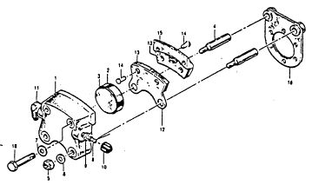
All four Brake pucks should be
replaced at the same time!

X. Fuel tank; the copper grounding net should not be torn, broken or deformed. The connecting wire to the aircraft grounding system must be intact. The mounting screws for the fuel quantity system should be checked for looseness. The lower side should be checked for leaks or seepage, especially the drain fitting.

Y. Airbrake drive couplings; the automatic couplings at the butt rib (male/female) should be checked for wear. An inside/outside caliper is suitable for this. Neither fitting should show excessive wear or deformity.

-33-

4.4 Test flights:

The following test flight work sheet should be filled out after each required inspection, or when a repair is performed that requires a test flight.

Item | Test flight Work sheet | Performance as specified
Item | Test flight Work sheet | Yes | No
1.  2.  3.  4.  5.  6.  7.  8.  9.  10.  11.  12.  13.  14.  15.  16.  17.  18.  19.  20.  21.  22.  23.  24.  25. 26  27  28.  29. 30.  31. | Fuel quantity Indicator  Anti Collision Lights  Navigation Lights  Avionics (VOR, ADF, VHF, XPDR, MKR, COMM)  Electric Boost Pump  Starter  Starting with cold engine  Oil Pressure Indicator  Voltmeter, Generator, Charging Rate  Tachometer  Cylinder-head Temperature  Brakes, Parking Brake  Oil Temperature Indicator  Taxiing  Propeller function, ground test  Take-off  Airspeed Indicator  Altimeter, QNH-function  Rate of climb Indicator, TEK  Magnetic Compass  Propeller, Flight check-climb/cruise positions  Cruise configuration, trim required  Slow speed, stall configuration  Airbrakes  Heater, Outside Air  Glider configuration, Propeller function/feather  Landing configuration  Landing  Shut down fuel shut-off valve, check  Open fuel shut-off valve  Re-start with warm engine
 | Pilot in command | Signature, | Date

-34—

4.5 Special Inspections:

Special inspections for the DIMONA are not required, except for the following:

1. Hard Landing; Should the aircraft have a hard landing, especially on a hard surface airfield, the following inspection should be performed:

a. Inspect landing gear where gear mates into fuselage. Inspect for cracks and deformity of gear legs and fuselage sides. Inspect mating surfaces of gear assy for damage. Inspect tires for cuts or damage. Inspect tail wheel assy for damage and attachment to fuselage structure.

b. Check antennas (if installed) beneath fuselage for security and damage.

2. Propeller strike; A prop strike can occur either on the ground, as a result of contacting the ground or an object or in the air, from a bird. The actions taken are the same.

a. If such a strike occurs on the ground, shut down engine and return aircraft to parking. Under no circumstances continue to run the engine or attempt to fly to the next airfield for maintenance. Measurement of the propeller flange for out-off-round will only indicate the condition of the prop flange and not the condition of the engine bearings or torsion stress on the crankshaft. Remove engine and inspect components for damage.

b. If a strike occurs in the air, shut down engine, feather propeller and continue in glider mode. Land as soon as practical. Perform maintenance as in par. 2a above.
-35-
Hoffmann Rigging
H 36 DIMONA

5. RIGGING

Table of contents

Paragraph Page
5.1 Rigging Diagram for Elevator and Dihedral ------------------ - 36
52 Rigging Diagram for Ailerons, Rudder and Wing Sweep - 37
5.3 Weights and Moments of Control Surfaces ------------------- 38
-36-

5.1 RIGGING DIAGRAM FOR ELEVATOR AND DIHEDRAL:

The following diagram illustrates the values from a factory rigged aircraft. The wing supports should be placed at the inboard portion of the ailerons, with enough lift to remove static drop.

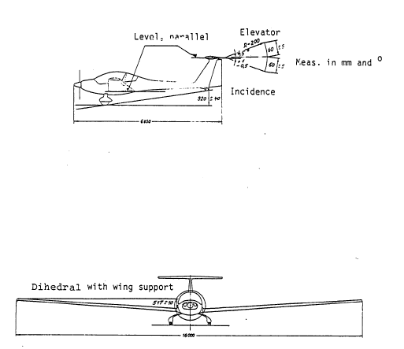
-37-

5.2 RIGGING DIAGRAM FOR AILERONS, RUDDER AND WING SWEEP:

The following diagram illustrates the measurements in mm for the rigging. The sweep can be measured from the fuselage side/wing leading edge to ascertain the sweep. Measurements are made at the factory and the sweep should not change, except from a repair or wing change.

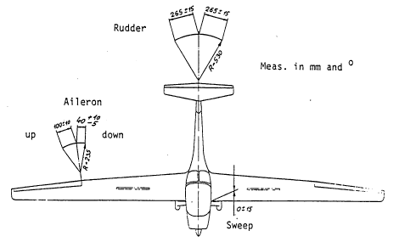
-38-
Hoffmann Rigging
H 36 DIMONA

5.3 WEIGHTS AND MOMENTS OF CONTROL SURFACES:

The control surfaces in the DIMONA are mass balanced components. The balancing insures the negation of flutter during high speed maneuvers. Should control surfaces be repaired or repainted, the units must be re-weighed prior to flight. The surfaces must be removed from the aircraft and supported by their hinge assemblies on a flat surface. Such a rigging jig can be easily made from some scrap steel angle and old bolts. The illustrated force “P” can then be applied to deflect the control. To measure the force required, a small spring scale can be used, with values to 1.5 kg (3.3 lb). Remember: 1 kg = 2.2 lb! Don’t forget when measuring the force required for surface deflection, the weight of the spring scale must be included as a part of “P” force. The arm “R” is from the hinge to the trailing edge. Should the repaired surface require an exchange of balance weights, the factory must supply these weights.

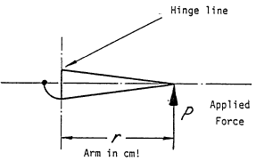

Approved weights and inertia in surfaces

 | Moment(kg/cm) | Surface weight(kg)
Elevator | +0,608  12,15  -1,458 | +0,514  2,57  -0,514
Rudder | +1,475  29,5  -3,540 | +0,853  3 88  -0,853
Aileron | +4,650  12,15  -4,650 | +1,100  2,80  -1,100

-39-

Hoffmann Weight and Balance
H 36 DIMONA

6. WEIGHT AND BALANCE

Table of contents

Paragraph Page
6.1 Determining C.G -------------- 40
6.2 C.G. Travel, empty aircraft ----- 41
-40-
6.1 DETERMINING CENTER OF GRAVITY:

If the aircraft has been newly painted, repaired (components exchanged) or extra equipment added, a new weight and balance plan should be computed. When the aircraft is delivered new from the factory the pilots handbook contains a weight and balance form completed at the factory for the aircraft and equipment installed at that time. After you receive your DIMONA, and, should extra equipment be installed, it’s necessary to re-compute the empty C.G. for that additional equipment.

a. Determining Empty C.G.

Prior to weighing the aircraft should be:

Completely assembled,
All interior items normally installed, i.e. seats, avionics, oxygen system, battery,
The following items should be removed: Parachutes, Wing Locking Lever
Empennage Braces, Wing Supports, Baggage, Extra Tools,
Canopy closed,
De-fueled,
Oil quantity 2.5 liters.

To weigh the aircraft, the DIMONA should be placed upon three scales. One under each main wheel and the other under the tail wheel. The aircraft should be leveled, using the lower side of the wing as the reference line. A straight edge can be laid on the butt rib and the level on the straight edge. When the aircraft is level, a plumb line can be dropped from the wing butt rib to the ground. The point where the plumb bob touches the RDL or Reference Datum Line.

The weights G₁ and G₂ can be determined from the scales. The two main wheel weights are added together to arrive at G₁.

The following formula is used to determine the CG position behind the RDL:

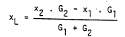

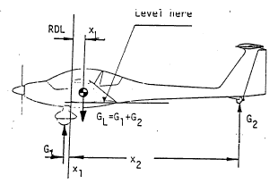
—41—
6.2 C.G. TRAVEL, EMPTY AIRCRAFT:

A further loading test is necessary, since the aircraft is also a glider. At the factory, the wing weight is included. The remainder of the aircraft weight is considered to be non-carrying or non-loaded parts. When the weight is computed, subtract the wing weight from the empty weight, add the max. useful load and the result will be “weight of non-loaded parts”. This weight must not exceed 560 kg. If it does, the maximum use— full load. must be reduced accordingly.

Approved Empty C.G. Range

Empty weight (kg) | 500 | 510 | 520 | 530 | 540 | 550 | 560 | 570
CG-Range (mm) | 326-356 | 325-357 | 324-357 | 320-358 | 319-359 | 317-359 | 315-360 | 314-360

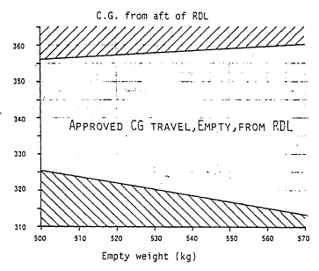

—42—

7. SERVICING

Table of contents

Paragraph Page
7.1 Lubrication Plan ------------ 43
7.2 Fuel and Oil --------------------- 44
7.3 Brake Fluid ---------------------- 44
-43-

7.1 LUBRICATION PLAN:

Most rod ends and bearings In DIMONA are maintenance free. However, depending on where the aircraft is flown and, the climate, these items should be inspected and cleaned as necessary. Other components requiring lubrication are listed in the chart below with a number depicting the place/item to lubricate. The number in brackets indicates to type of lubrication. The lubrication check list should be copied and added to the inspection check list as a reminder that the lubrication is to be performed.

Lubrication Diagram

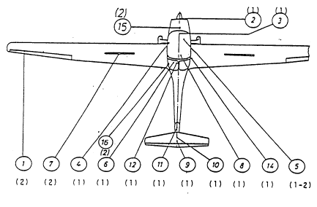

(1) = Grease, aircraft, applied by hand

(2) = Oil, aircraft engine, applied .with oil can

CAUTION

Do not use any lubricants containing MoS₂ Moly/Silicones. These can smear the surfaces, and should a repair be required, make the repair very difficult. Use standard aircraft lubricants.

-44-

1. Aileron hinge, 2 each  2. 4 thrust rods, pitch change, propeller  3. Prop pitch change lever, throttle lever  4. Canopy locking & Ejection unit  S. Pedal adjustment unit, cable guide & cable  6. Torque tube for Airbrakes  7. Torque tube for airbrakes in Wing  3. Main Bolts  9. Elevator drive fork (empennage removed) 10. Rudder bearings (Rudder removed)  11. Tail wheel bearing and steering unit  12. Rudder transfer unit (under baggage compartments) 13. telescopic push-pull tube  14. Airbrake and Aileron connections in wing butt rib  15. Magneto Latch  16. Additional metal fitting | Sequence—hours
 | 50 | 100 | 500
 | 0  0  0  0  0  0  0  0  0 | 0  0  0  0  0  0  0  0  0  0  0  0  0  0 | 0  0  0  0  0  0  0  0  0  0  0  0  0  0  0  0

7.1 FUEL AND OIL:

Approved fuels are AVGAS 100 LL or automotive fuel “SUPER”. The aircraft should be grounded during refueling. The most available ground is the exhaust pipe. The fuel should not be pumped in at full flow since the air vent may not handle the quantity and overflow may result. The tank filling capacity is 80 litres.

The oil is added thru the oil filler neck on the engines’ top side. The oil quantity is 2.5 litres. Refer to the flight manual for oil quality.

7.3 BRAKE FLUID:

The Brake Fluid used is SAE J 1703 (SAE 70 R3) or FMVSS 116 DOT 3. The aircraft MIL-5606 is NOT to be used (RED). When adding fluid, pay attention the fluid does not spill over on painted surfaces. Insure the cap for the reservoir can vent to the atmosphere. Before adding Brake Fluid, attempt to determine why fluid is needed.
-45-
Hoffmann Repair
H 36 DIMONA

8. REPAIR

Table of contents

Paragraph Page
8.1 General ------------------------------------ - 46
8.2 Repair of Fibreglass components ---------- 46
8.3 Damage to Fibreglass Sandwich parts ------ 53
8.4 Damage to pure Fibreglass parts ---------- 55
8.5 Damage. to Roving Stringers ---------- 55
8.6 Plexiglass Repairs ---------------------------- 55
8.7 Painting ------------------------------------- 55
8.8 Repairs to Fittings and Controls ---------- 55
8.9 Propeller repair ---------------------------- 56
8.10 Major repairs ------------------------------------- 56
-46-

8.1 GENERAL:

The H 36 DIMONA is constructed mainly from fibreglass. All of the components, i.e. fuselage, wings etc. are made in a negative form, thereby producing a positive product. Thus a superior finish can be obtained, when the components are released from the mold. For all repairs cited in this manual, there are three important things to remember when working with fibreglass products.

a. Cleanliness
b. Temperature
c. Humidity

All three of these play an important part in the repair of fibreglass structures, if the repair is to have the same bonding, and strength properties as the original item.

8.2 REPAIR TO FIBREGLASS COMPONENTS:

a. Wing assembly; The load carrying components of the wing are a sandwich skin and a spar
with stretched glass rovings with vertical-sandwich spacers. Due to a high aerodynamic torsion effect
the wing skin is reinforced. The outer skin consists of 450 glass cloth with a bonded support structure
of 8 mm thick Conticell 60. In the area where the air-brakes are installed, the reinforcement is not
disturbed, but molded to accept the thin (also reinforced) air brake. In the immediate spar area, the
spar is bonded to the outer skin, and the sandwich glass/Conticell is absent in this area only. The spar
is box form for the first 4.4 metres, then changes to I-form for the remainder of the span. The
fibreglass spacers are reinforced with Rohacell 71, 8 mm thick. The spar penetrates the fuselage to
the centerline and each spar is attached to the fuselage with three bolts. One bolt, in the centre-line,
lies fore and aft. The other two bolts are secured to the butt rib of the fuselage and face outboard.
These bolts carry the torsion wing loading and the bending moment of the wing assembly. The main
box spar in the fuselage serves as a bridge for the two spars when the wings are both assembled.

The butt ribs and spar web are fabricated in one piece and are bonded together with the butt rib (wing/fuselage) top and bottom skins. Repairs to the main spar, butt rib and spar butt may only be made by the manufacturer or an approved repair station!

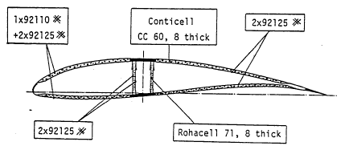
All Fibreglass numbers indicate INTERGLASS quality

Weave direction 45* to spar (X)

-47-

b. Ailerons; The ailerons are made from two skins and bonded together. Carbon fibre is used to
reinforce the aileron against torsion loading. The glass weave direction is 45*, similar to the wing
assembly. The hinge assembly for the aileron is a stainless steel piano type hinge along its entire
length. To distribute the loads a 15 mm wide aluminium strip is bonded to the inner side of the
aileron and wing to accept the hinge rivets. To remove the aileron, the push-pull tube must be
disconnected (6 mm bolt). The aileron will then deflect downwards, exposing the entire piano hinge.
The securing rivets can be drilled out using a 3 to 3.2 mm drill. To replace the hinge assembly, a
hand rivet gun may be used with:

Cherrymax Rivets CR 2248-3 (1/8” dia.) or
Avdel Rivets, Type 4002/3.2x7.l Al, LN 9314 (3.6 mm dia.)

The removal of the aileron is only necessary, when major damage occurs to the aileron or to the wing in this area. If the aileron is repaired, the aileron must be rebalanced (refer to rigging)!

Aileron cross section

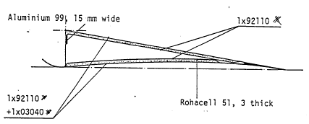

c. Rudder; The rudder is constructed from two sandwich skins that have the weave 45* to
vertical. The roving reinforcement stringers start at the top, continue downward, around the lower
hinge point and continue aft to the rudder tip. The rudder profile is obtained and reinforced thru
conticell ribs. The lower rudder bearing is formed from a “U” shaped metal plate, to which the
rudder cables are attached. The bearing plate is screwed to a plywood reinforcing rib, bonded to a
glass rib. This permits induced and dynamic rudder loads to be distributed thru-out the entire rudder.
The top rudder bearing is a brass bushing, bonded within a fibreglass unit. The bearing is secured to
the fuselage with a 6 mm bolt.

8.2 REPAIR TO FIBREGLASS COMPONENTS (cont):

To remove the rudder, first remove the horizontal stabilizer and elevator assembly. Then remove the two rudder cables (two 6 mm bolts). Remove the third 6 mm screw (middle) and the rudder is free on its lower hinge. The rudder can then be easily removed by canting the lower portion aft, then lift the entire assembly vertically.
Assembly is the reversal of the above. Do not forget to safety the three 6 mm screws!

-48-
Rudder cross section

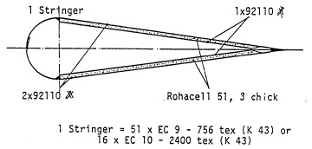

d. Horizontal stabilizer/Elevator; The construction is similar to the sandwich method before.
Two butt ribs act as load spreaders to transfer the torsion loads to the mounting fixture. Glass roving
stringers absorb the bending and compression loads. In the outer spar spacers, fixture boxes are
installed that accept the wing support fixtures. Attached to the main spar are two guide bearings that
face fore and aft. These two bearings mate up with two mounting pins on the vertical fin fitting. On
the nose of the stabilizer is a rod end bearing that also slides into a guide pin on the fin assembly. The pins are all bonded into the fin assy and reinforced with doublers. To remove the elevator, remove the safety wire on the three 6 mm screws, remove the screws and the rudder is free.

To install the rudder, reverse the procedure. Do not forget the safeties! Following painting or repairs, the elevator must be rebalanced! Repairs to the spar or areas containing fixtures can only be made by the manufacturer or an approved repair facility.

-49-

Horizontal stabilizer cross section

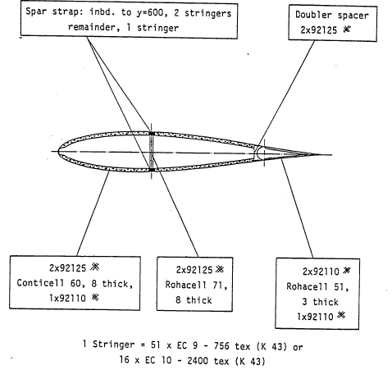
-50-

e. Fuselage; The fuselage structure is made from two half skin assemblies, without the
supporting layer of Conticell. The diagonal laying of glass cloth accepts the compression forces,
derived from the empennage loads, while fore and aft loading and bending moments are negated by
roving stringers. The stringers in the main fuselage area are heavily reinforced. The lower stringers
support the seat assembly, the top stringer form the cockpit rim. Aft of the wing bulkhead the
stringers transfer to a “Z” shape and continue aft to the empennage. In the forward fuselage section,
the stringers continue forward to the first fuselage station. In the aft fuselage boom section, the
stringers are reinforced every 500 mm with fibreglass formers. In the cockpit area, main knee support, seats, middle and side consoles are made as an integrated unit. The main knee support accepts the loads from the landing gear. The middle and side consoles are reinforced with roving stringers, fore and aft, to prevent engine aft movement in a forced landing.

The main bulkhead serves as a spar bridge for the wings spars. The forward wall of the bulkhead carries the forward wing bolts and the main bolts in center fuselage. The forces are therefore divided between the front walls of the bulkhead. The dynamic forces exerted upon the main bolts are transferred to a spreader plate, that is installed with massive vertical roving stringers. The rear wing bulkhead is reinforced against lateral compression loads. The transfer of the eccentric bolt loads is done by weaving the roving stringers around the bolt guide tube. The open area in the bulkhead serves as a bed for the fuel tank.

Repairs on the main bulkhead and the bonded fittings are to be made only by the manufacturer or an approved repair facility.

-51-

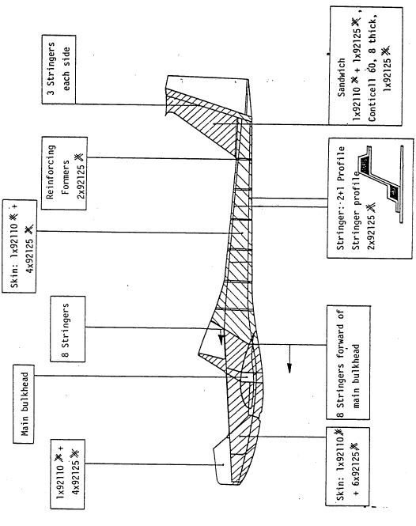
-52-

f. Landing gear; The two legged landing gear is equipped with 6.00 aircraft tires and wheels. The gear assembly is made from fibreglass, with built-in fairings, that additionally carry the loads for the wheel mount. Diagonal glass cloth is used for the outer skin, which absorbs the compression loads. The bending loads are absorbed by rovings, which are bonded to the outer skin. The inner area is filled with Conticell 60, cut to profile. Above the wheel mount, the rovings wrap around the axel assembly, which is bonded in place with a steel reinforcing plate. Side loadings are absorbed by doublers, built into the inner area of the gear legs. A second function of the doublers is to guarantee perfect bonding of the top and bottom components. The gear leg assembly mounts into the fuselage beneath the knee support on two steel fittings. The gear assembly is held to the fittings by four reinforced rod ends. Thus, bending of the gear legs is not disturbed by the mounting at the fuselage. Side loads are transferred to Form fit Rubber Blocks, reinforced with rovings on the top of the gear legs. The wheels are braked hydraulically, using a disc. The brake fluid lines are attached to the lower aft side of the gear legs.

To remove the landing gear, the brake lines must be disconnected at the center fuselage station fitting. The four 10 mm nuts are removed and the steel fittings removed. The landing gear can then be removed by lowering it from the fuselage. The installation is a reverse of the above. When installing the gear assembly, don’t forget the following:

1. Rubber Shock Mounts in Gear Tunnel,
2. Bleeding the Brake System.

Repairs on the gear assembly should be made after contacting the manufacturer.

g. General; Instructions for repair of fibreglass parts: Should the aircraft become damaged, the extent of damage should be immediately be determined. When a hard landing has occurred, the aircraft should be inspected, even though no visible damage is apparent. Cracks in the finish or flat white areas are especially suspect of hidden damage. Should there be doubt if the crack or suspect area is damaged, the paint should be removed for a more complete inspection. Steel fittings, such as shear bolts and empennage supports should be suspect of crack or fine white lines, indicating fatigue. The manufacturer has experience in repairs and their detection. Should questions arise, the factory should be contacted immediately.

Repairs to the H 36 must be made with care and precision. Since the outer skin in the fuselage is a load carrying member, faulty workmanship in this area can lead to a disaster!

It is very important that the resin mixture be exactly proportioned. The mixture should be within
+0.5 %. Use only a clean container. Large paper cups (16 & 24 oz.) are available in any supermarket. Use only a new brush to apply the resin and throw it away when the task is finished. The risk of a brush being contaminated with oil or silicones is too great to have it lie around and become contaminated. The weight of resin mixture to fibreglass cloth or rovings should be 50/50. That means when a repair is made, cut the fibreglass cloth to complete the repair. Weigh it on a stamp scale. The determined weight should the be the amount of finished resin mixture. Before the impregnated glass cloth is applied to a repair, sand the area around the repair. This will eliminate any dirt or foreign matter to negate good bonding. The sanded area should not be touched after sanding. The area should then be cleaned either with a vacuum cleaner or air blast. Before the glass cloth is applied, the area should be coated with resin mixture.

As when working with plywood, the weave direction is of great importance, The markings X which is Diagonal or +, which is straight application play an important role in the final structure strength. When a repair is made and the damaged material removed to prepare for new laminate, the old material should be examined for the direction of weave.

-53-

The new repair should compliment this weave direction. In addition, in the various diagrams concerning structure, illustrations are made as to weave direction by the symbols: X and +. The diagrams also dictate the number of layers to be applied. When not be evident pictorially, then measure the thickness of the repair area and duplicate it. A layer of cloth Nr.92125 has a dry thickness from 0.4 mm. A piece of the old damaged material can be removed and ignited. The resin will burn and the remaining un-burned cloth can then be measured. Scarf repairs require more work, but, look better and improve the strength of the repair. Take the time to do professional work.

To increase the set and hardening time, heat may be applied to accelerate the repair. Use a heat lamp, infra-red or a hair dryer. The best method is to build a small tent over the repair area and apply heat within the tent and not directly on the repair. This will eliminate the possibility of blisters in the finished repair. To complete the repair process, the repaired area should be “tempered” at a temperature of 65 C for 14 hours to fully cure the repair and to reach the maximum strength. The small tent, with a small electric heater is excellent for this, is economical and safe.

A final note on resins: On all the instruction labels “pot life” is given in minutes at a certain temperature. Pay close attention to this time. Do not mix the resin, then start the repair. To the contrary, complete the repair, prepare the fabric, clean the area, then mix the resin and commence work. This is especially true with resins with accelerators in them. Two batches of resins should not be applied to the same repair, in wet form, since the mixing times and subsequent “set times” are different.

Many people have an allergy for fibreglass and the related products. If the work is done properly, there should be no skin irritations or discomforts. When using the resins wear “throw-away” plastic gloves. They can be purchased from any drug store for very little costs.

8.3 DAMAGE TO FIBREGLASS SANDWICH PARTS:

There are two common damages to sandwich components. They are fractures and breaks. The difference is easy to determine. A fracture is where the outer skin is cracked, but the lower layer is undamaged. A break is a complete break through the sandwich construction.

a. Repairs to fractures; Take a coin and tap around the area to determine the extent of the fracture. The delaminated or un-bonded area will emit a dull sound, while the intact material will have a solid sound. The un-bonded outer skin can the be removed with a small disc sander, a sanding block or a sharp knife. Be very careful not to cut into the un-damaged sandwich material underneath! When the entire un-bonded area has been removed, attempt to make it circular or oval. If necessary sand or cut into healthy material to do this. Then chamfer the edges of the repair 1:50. That means for the single layer cloth Nr.92125 a chamfer of 20 mm. Clean the area and pay attention that the pores of the sandwich material are also open and clean. Should oil or silicones come in contact with the area, make a final cleaning with acetone. Should a indent or abrasion in the sandwich material be present, fill this cavity with microballoon until the area is level with the outer sandwich surface.

NOTE
The microballoons are to be used only, when the fracture does not extend through the sandwich material!

Then impregnate the area with resin. Start laying the glass cloth patches into the repair area, full size first, then the smaller until the repair is covered. Allow to harden, then cure. The area may then be sanded (not the repair center, only the edges) and prime to produce a perfect repair. After final sanding with Nr. 400 or 600 wet/dry paper, the area may be painted. To ensure a perfect repair, allow the full time to harden and cure. Un-cured repairs will not sand well, not accept a primer or produce a good finish.
-54-
Typical Fracture and Laminate Repair

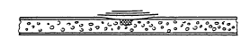

b. Repairs to breaks; When it had be determined that a break exists, the first step is to remove the outer laminate that is un-bonded with the sandwich material beneath it. The inner material is then removed to its limits of un-bonding. In order to repair the inner laminate another area of sandwich material must be removed until a rim of inner laminate 20 mm wide is available. The outer skin is then chamfered, as in par. A. Then clean the inner layer of material and chamfer it also as in par. A (see sketch).

Typical Break and Repair
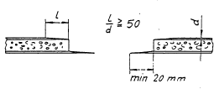

For small repairs, a piece of aircraft grade plywood is bonded within the hole as a inner doubler. This is easily achieved, when the hole and the plywood is oval. A nail thru the plywood allows it to be held tightly against the inner wall while curing. The plywood doubler should be larger than the repair and slightly larger than the glass cloth repair patch(s) that it is hold against the inner surface (see sketch). After curing, remove nail.

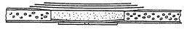

Clean the area, also the interior with vacuum cleaner. Apply resin mixture to the plywood doubler and then lay the necessary layers of impregnated cloth in proper weave direction on the plywood. Lay the cloth laminate on the chamfered edges of the inner skin. The hole can then be filled with microballoon/resin mixture to the chamfer edge of the outer skin. Allow the repair to harden/cure. For the repairs of larger holes, it is advisable to cut a insert of filler material (conticell or rohacell 71). The insert should be a tight fit for the hole. The pores of the inner surface should be closed with resin and microballoons and the inner laminate applied. The nail holder may again be used to hold the repair in place. After the insert is in place, apply resin/microballoons around the edges, so it seeps down between the two surfaces, completing the bond. Allow to harden and cure. After curing, sand the insert until the chamfer edges of the outer skin are clean. Apply a mixture of resin and cotton fibres (cotton balls work well) to the top surface of the insert, then apply the outer laminate cloth repair patches as in par. A. When this has hardened and cured, sand, prime and paint as in par. A.

NOTE

Don’t forget the order to follow for repairs
1. Prepare the repair area
2. Prepare the repair material
3. Clean the area
4. Mix the resin/microballoons
5. Complete the repair
6. Control temperature, allow to harden and cure
-55-

8.4 DAMAGE TO PURE FIBREGLASS PARTS:

The repair area is chamfered as in 8.3 par. a. (1:50). Clean the area with acetone. For small areas the cloth laminate may be directly applied to the chamfered surface. For larger areas, the plywood doubler may be used to reinforce the lower surface and prevent sagging of the laminate repair. Pay attention to weave direction! The plywood doubler should be the size of the repair plus 20 mm in all radials larger.

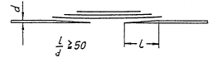

8.5 DAMAGE TO ROVING STRINGERS:

Repairs to stringers are one of the most complicated repairs to accomplish. Therefore, only personnel with considerable experience in fibreglass work and repair should accomplish this work. The outer skin should be removed to the extent where the stringers are no longer bonded to the skin. Tapping with a coin can determine where the un-bonding has occurred. The stringer ends, i.e. the inner (2) and outer (20) must be scarfed, that a bonding surface of 2800 mm² exists. This dimension is for each stringer surface. Example: The un-bonded/damaged area is 650 mm long. The stringer width is 15 mm. 2800 / 15 = 186. This means, that each roving must be chamfered at each end of the repair area 186 mm plus the length = 650, 50 the total repair length will be 186 + 650 = 1022 long. From thin aluminium sheet stock a form can be made to fit the stringer profile. The form is set in place and a layer of X 92125 laid within, then the three rovings, then another layer of X 92l25. All 92125 for stringers is laid diagonally (X). After hardening, the aluminium form is removed and the stringer allowed to cure. The outer skin is then repaired as explained in 8.4.

8.6 PLEXIGLASS REPAIRS:

Should a crack in the plexiglass canopy be discovered, the hole should be stop drilled immediately. This will relieve the stress around the crack and prevent it from going further. If the crack is longer than 10 mm, then it should be repaired. The sides of the crack should be beveled and cleaned. Then apply plexiglass cement to the groove (Acrifix 92). This cement hardens only in sunlight, so the canopy should be exposed to direct light. If that is not possible, a sun lamp will be of use. After the cement hardens, clean the bonded area with a small scraper and polish out with a good plastic polishing compound.

8.7 PAINTING:

After repairs and the area has cured, sand the area with Nr. 80 dry paper to remove the major unevenness. Then use a quality filler, re-sand with Nr. 150 dry paper. Then clean the area with air blast. A small brush can be used to apply the paint, three or four coats and allow to dry. Then sand the area with Nr. 360 wet paper. The final coats can then be applied and wet sanded with Nr. 600 wet paper.

8.8 REPAIRS TO FITTINGS AND CONTROLS:

Repairs to fittings and steel control parts should be made after consulting with the manufacturer. The steel most used is 1.7734.4 that is weld-able only with inert gas (Argon) TIG-welding (see Chap. 9 for U.S. equivalents).
-56-
8.9 PROPELLER REPAIRS:

For repairs to the propeller, refer to the furnished manual, maintenance and repair, HO-V 62, furnished by Hoffmann Propeller, Rosenheim, West-Germany.

8.10 MAJOR REPAIRS:

Major repairs are to be accomplished by either the manufacturer or an approved repair station, recognized by the manufacturer. Major repairs are classified as:

a. Broken Wings, Fuselage, Empennage, Rudder, Spar Butt, Landing Gear, Bulkheads,
b. Major Fittings that have been damaged or forcibly removed
c. Damaged Fibreglass Laminate (Cracks, Un-bonding) that occurs in immediate areas surrounding Main Fittings.

In any event, should doubt arise as to the definition of major repair. The manufacturer should be contacted.
-57-

9. MATERIALS

Table of contents

Paragraph Page
9.1 Spare Parts --------------------------- - 58
9.2 Steel ------------------------------------- 58
9.3 Non-ferrous and Alloy Metal ------- 58
9.4 Plastics ---------------------------- 58
9.5 Fibreglass and related products ----- 58
9.6 Consumable materials --------- - 59
-58-
9.1 SPARE PARTS:

The spare parts for the DIMONA are listed in the maintenance handbook. The dealer who supports your aircraft has a complete basic set of “wear and tear” parts for your aircraft. These include tires, brakes, hoses, hardware and the correct fibreglass/resin combinations to complete minor repairs.

NOTE
The manufacturer assumes no responsibility for repairs made to the aircraft, when the materials used do not conform to the manufacturers standards or specifications.

9.2 STEEL:

The alloy most used in the manufacture of the DIMONA fittings and controls is 1.7734.4. The U.S. equivalent is SAE

9.3 ALUMINIUM AND NON FERROUS METALS:

DIN Material U.S.
AlCuMgl, 3.1325.1 Aluminium Sheet
AlCuMgl, 3.1325.3 Aluminium Sheet
AlCuMgl, 3.1325.5 Aluminium Sheet

9.4 PLASTICS:

Plexiglass Cement, Roehm, 6100 Darmstadt, West Germany, Acrifix 92

9.5 FIBREGLASS AND RELATED MATERIALS:

Material Manufacturer
Resin, Rutapox L 20 Bakelite Co. 4100 Duisburg, West Germany
Hardener, VE 2896 Bakelite Co. 4100 Duisburg, West Germany

Rovings, EC 9-756 (K 43) Gevetex Textilglas, 5100 Aachen, West Germany
Fibreglass cloth,
92110 (161 g/m² ) Interglass Textil, 7900 Ulm, West Germany
92125 (276 g/m ² ) - “ -
Carbon fibre cloth:
03040 (200 g/m²) - “ -
Sandwich material:
Conticell CC 60, 8 mm Continental, 3000 Hannover, West Germany
Rohacell 71, 8mm Roehm Co., 6100 Darmstadt, West Germany
Rohacell 51, 3 mm
Fillers:
Micro Balloons BJO-0930 Brenntag Co., 4300 Muelheim, West Germany

-59-
Fire wall paint:
Wiedokoll T 508 (White) Wiederhold Co., P0 Box 4010, Hilden, West Germany
N 56582

Paint and Primer:
Consult your dealer for a compatible paint/primer system for your aircraft. Any acrylic paint system of quality can be used to touch up or re-paint the aircraft.

9.6 CONSUMABLE MATERIALS:

Consumable Materials are materials which are used in the care & maintenance of the aircraft. These include oil, fuels, polishes, cleaners etc. Any quality brand names can be used providing they do not contain silicones. The labels should be read carefully to determine the contents and the mention of silicones.

Greases and lubricants should be of aircraft quality and these brands are mentioned in the flight manual for your use.

Cleaning the plexiglass canopy should be with a cleaner designed for plastic surfaces. The Permatex company makes an excellent cleaner for this purpose and is available at most aircraft parts supply houses. Never use gasoline, lacquer thinner or acetone to clean plexiglass!

The outer surfaces of the DIMONA can be cleaned and polished with any quality automotive/aircraft cleaner and wax polish providing it is free from silicones.
-60-

10. Airworthiness Limitations

Table of contents

Paragraph Page
10.1 Airworthiness Limitations ------------------------------------ - 61
10.2 Log of Revisions for the Airworthiness Limitation Section - 62
10.3 General ------------------------------------------------------- 62
10.4 Inspection procedures to extend Life-time ------------------- 62
10.4.1 General ------------------------------------------------------- 62
10.4.2 Extensions ------------------------------------------------------- 62
10.4.3 ---------------------------------------------------------------- 62
1 0.4.4 ---------------------------------------------------------------- 62
10.4.5 ---------------------------------------------------------------- 62
10.4.6 ---------------------------------------------------------------- 63
10.5 Equipment with limited Service Life ------------------- 63
10.6 Aircraft components with limited life time ------------------- 64
—61—

10.1 Airworthiness Limitations:

The Airworthiness Limitations Section is FAA approved for U.S. registered gliders in accordance with the provisions of 14 CFR section 21.29. In addition, this section is required by FAA Type Certificate Data Sheet No. EU and it specifies maintenance required under 14 CFR sections 43.16 and 91 .163, unless an alternative program has been FAA approved.

10.2 Log of Revisions for the Airworthiness Limitations Section:

Revisions No. | Pages affected | Description | BAZ approval signature | Date
—62—

10.3 General:

Repair damaged wings, fuselage and tail surfaces prior to next flight. Repairs outside the scope of BAZ-approved Hoffmann H 36 DIMONA repair instructions, dated May, 1984 and major repairs must be accomplished at FAA certificated repair stations rated for composite aircraft structure work in accordance with BAZ-approved Hoffmann repair methods or using other methods acceptable to the FAA.

10.4 Inspection procedures to extend Life-time:

The approved life-time limits of the GRP airframe is 3000 flight hours. The life-time limits may be increased after appropriate inspections to 6000 hours (mm.).

10.4.1 General:

The results of the fatigue tests of wing spar sections have demonstrated recently that the service time of GRP gliders may be extended to 6000 hours, if for each individual glider (in addition to the obligatory annual inspection) airworthiness is demonstrated according to the special multi-step inspection program particularly with a regard to the service life.

10.4.2 Extensions:.

If a motorglider reaches a service life of 3000 hours, an inspection according to 10.4.3 (below) is required. After a positive result or qualified rectification of any faults, the service life of the motorglider will be extended by 1000 hours, which is to say, to a total of 4000 hours (first extension).

The above inspection program is to be repeated after the 4000.hour mark is reached. After positive inspection or repair, the extension will be granted to a total of 5000 hours (second extension).

After similar actions, an extension from 5000 to 6000 hours flying time is possible (third extension).

For a possible service time exceeding 6000 hours, procedures will be evaluated in the future.

10.4.3

In each case the latest issue of the BAZ-approved inspection program, which will be updated according to incoming inspection results, has to be ordered from the manufacturer.

10.4.4

The inspections have to be made by the manufacturer or an approved aviation repair facility rated for composite aircraft structure work.

10.4.5

The results of the inspections have to be compiled in a test report with details of each test and subsequent repair. If the inspections are done outside the manufacturers facility, a copy of the record must be send to the manufacturer for his evaluation and information.
-63-
10.4.6
The annual inspection according to § 40; ZLLV, Bundes-gesetzblatt 415, Aug 17 1985 or applicable foreign procedure.. as prescribed by regulations in the country of registration is required regardless of above steps.

10.5 Equipment with limited Service Life:
If equipment with limited service life is installed, the appropriate inspection dates and time intervals between renewal have to be observed.
For instance, Overhaul times for specific oxygen equipment is given in their test certificates.
Oxygen bottles must also be checked by the technical services every 5 years or according to the local regulations on use of pressurized gases.
There may be other national requirements calling for replacement of emergency shutoff valve and rubber hoses after 5 years of service.

10.6 Aircraft components with limited life time:

a) Engine: The recommended TBO of the Limbach engine is 850 hours. Extended TBO will be published by service bulletins of the manufacturer.

b) Propeller: The recommended TBO for the propeller assembly is 600 hours or every 4 years, whichever comes first. Extended TBO will be published by service bulletins of the manufacturer.

c) Magnetos: The Slick Magneto (4230) and Bendix Magneto (54RN21) have a TBO of 1000 hours. At 500 hours they must be inspected

d) Rudder cables: The Rudder cables can be controlled during normal inspection intervals. Should excessive wear be found, the cables should be replaced. When no wear is discovered, the cables are to replace every 5 years or 1000 hours, whichever comes first.

e) Tail wheel steering cables: life time 1000 hours of operation or 10 years

f) air brake control cable: life time 1000 hours of operation or 10 years

g) silent blocks of engine mount: life time 3000 hours of operation

h) engine tension-cables and turnbuckles: life time 3000 hours of operation

i) electric fuel pump, part no. 4412: life time 1500 hours of operation

j) electronic fuel pump part no. 8812: life time 3000 hours of operation

k) fuel shut-off valve, type Truma 8L: life time 3000 hours of operation or 5 years

1) fuel tank made of FRP: life time 3000 hours of operation

m) rod end bearings, fastening screws, and
brackets of main landing gear attachment: life time 3000 hours of operation

n) outer rod end bearings of elevator attachment: life time 3000 hours

o) flexible fuel and hydraulic lines of airframe / cell: life time 8 years

p) flexible fuel and oil lines of engine compartment: life time 5 years

