HOFFMANN AIRCRAFT

HOFFMANN AIRCRAFT CORP.
P.O. Box No. 100
A-1210 Vienna
Austria
Phone (0 22 2/2536 21 or 25 3635

FLIGHT MANUAL

H36 DIMONA

This Flight Manual must be carried on board of the motorglider at all times.

This Flight Manual is FAA approved for U.S. registered gliders in accordance with the provisions of 14 CFR Section 21.29 and is required by FAA Type Certification Data Sheet No. …………………

Reg. No. …………….. Ser. No. …………………….

Owner : …………………………………………………..
…………………………………………………..
…………………………………………………..

Austrian edition of operating instructions is approved under § 33 ZLLV, Bundesgesetzblatt 415,
Aug 17 1983

Published Nov 15 1985 BAZ—approved on Nov. 22 1985

Approval of translation has been done by best knowledge and judgment. In any case the original text in German language is authorative.
1

Section 0 Hoffmann Flugzeugbau

Revisions H 36 Dimona

PILOTS OPERATING HANDBOOK

LOG OF REVISIONS

Revision Number and Date | Revised Pages | Description of Revision

All manuals for the Hoffmann H 36 can be ordered from:

Hoffmann Aircraft, Richard — Neutra — Gasse 5, P.O. Box 100, A — 1214 Vienna / Austria

WARN ING~

This handbook should not be used for operational purpose unless it is maintained in a current status.

0-1
2

Hoffmann 1
H 36 DIMONA General

THIS HANDBOOK CONTAINS IMPORTANT INFORMATION FOR THE PILOT!

This information is broken down into informative sections in the order shown below.
Section 0 ------------------ Revisions
Section 1 ------------------ General
Section 2 ------------------ Limitations
Section 3 ------------------ Emergency Procedures
Section 4 ------------------ Normal Procedures
Section 5 ------------------ Performance data
Section 6 ------------------ Weight and Balance/Equipment List
Section 7 ------------------ Motor Glider and Systems Descriptions
Section 8 ------------------ Aircraft Handling, Service & Maintenance
Section 9 ------------------ Supplements

1—1
3

Hoffmann 1
H 36 DIMONA General

Table of Contents
Section 1
General

Paragraph Page
1.1 Introduction ------------------------------------------------ 4
1.2 Three view drawings --------------------------------------- 4
1.3 Description ------------------------------------------------ 5
1.4 Engine ------------------------------------------------ 5
1.5 Propeller ------------------------------------------------ 5
1.6 Approved Fuels --------------------------------------- 5
1.7 Approved Lubricants --------------------------------------- 6
1.8 Maximum Certified Weights ------------------------------ 6
1.9 Symbols, Abbreviations and Terminology ------------ 6

1 — 2
4

Hoffmann 1
H 36 DIMONA General

1 . 1 Introduction:

This handbook contains material required to be furnished to the pilot by JAR 22. It also contains supplemental data supplied by the airframe manufacturer. Each section is divided by tab markers with Emergency Procedures tabbed in red.

1.2 Three View Drawings:

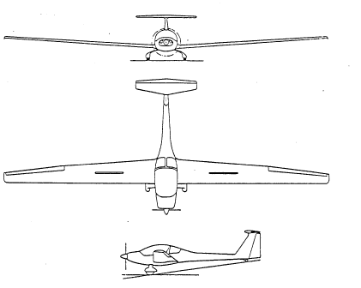

1 — 3
5
Hoffmann 1
H 36 DIMONA General

TECHNICAL DATA

Wing Span ----------- 16,0 Meters ( 52 ft.)
Length ----------- 6,85 Meters ( 22 ft.)

Wing Area ----------- 15,20 m² ( 164 sq. ft.)

Wing Ratio ----------- 16,8
Maximum Gross Weight -- 770 kg (1698 lbs.)
Maximum Wing Loading -- 50,7 daN/m² ( 10,38 lbs/sq. ft.)
Airfoil -------------------- Wortman FX 63-137

Engine -------------------- Limbach L 2000 EB 1.C (59 kw/80 hp. rated at 3,400 Rpm)

Propeller ------------------- Hoffmann Ho—V 62 R/L 160 T or. L 160 BT

1.3 Description:

The Hoffmann H 36 DIMONA is a two seat motor glider constructed from glass fiber. Design features are unbraced wing, T-type stabilizer, fixed landing gear with steerable tail wheel. All three wheels are covered with fairings. Seating arrangement is side—by—side. Air brakes are provided in the wings upper surface. The aircraft is certified in accordance with JAR 22 in the UTILITY CATEGORY.

1.4 Engine:

Limbach L 2ooo EB 1.C,Four cylinders, opposed, air-cooled, direct drive. The engine produces 59 KW/80 Hp at 3.400 RPM.

1.5 Propeller:

Hoffmann Ho—V 62 R/L 160 T or , L 160 BT, two blade with a diameter of 160 cm ( 63 inches). The propeller has three pitch positions controlled by the pilot.

1.6 Fuel:

The approved fuels are Aviation Grade 100 LL or Automotive fuel ‘Super’. The capacity of the fuel tank is 83 liters 22 gal. ) . The total usable fuel is 83 liters ( 22 gal)

1—4
6

Hoffmann 1
H 36 DIMONA General

1.7 Approved Lubricants:

Automotive lubricants with SAE ratings compatible with the seasonal temperatures.
Refer to Section 8, Servicing for lubrication usage chart.

CAUTION

Under no circumstances should Aviation Grade oil be used!

1.8 Maximum Certified Weights:

The maximum allowable take off weight is 770kg (1698 lbs.)

Maximum weight for non-lifting parts is 560 kg (12361bs.)

1.9 Symbols, Abbreviations and Terminology:

Liters Ltr.
Ki1ogramms Kg
Indicated airspeed IAS
Indicated airspeed in Knots KIAS
Maneuvering Speed Va
Max. speed in rough air Vb
Stalling Speed Vso (Airbrakes retracted)
Max. speed not to be exceeded Vne (calm air)
Max. speed with flaps extended Vfe
Stalling speed Vsl (Airbrakes extended)
Max. speed with airbrakes extended Vle

1-5
7
Hoffmann 2
H 36 DIMONA Limitations

Table of Contents
Section 2
LIMITATIONS

Paragraph: Page
2.1 Category of Airworthiness ------------------------------------ 8
2.2 Permitted Operations --------------------------------------------- 8
2.3 Minimum Equipment --------------------------------------------- 8
2.4 Engine Limitations ------------------------------------------------------ 9
2.5 Oil Pressure ------------------------------------------------------ 9
2.6 Oil Temperature ------------------------------------------------------ 9
2.7 Cylinder Head Temperature -------------------------------------------- 9
2.8 Voltmeter -------------------------------------------------------------- 9
2.9 Airspeed Limitations and Load Factor Limits ----------------- 10 - 11
2.10 Airspeed Indicator Markings ------------------------------------ 12
2.11 Crew Requirements ----------------------------------------------------- 12
2.12 Weights --------------------------------------------------------------- 12
2.13 Center of Gravity Limitations ------------------------------------ 13
2.14 Placards and Markings --------------------------------------------- 14 - 17

2—1
8
Hoffmann 2
H 36 DIMONA Limitations

2. Operating Limitations

2.1 Category of Airworthiness

Utility (U) according to JAR 22
Certifications basis: JAR 22 (Joint Airworthiness Requirements for gliders and motorgliders)
effective 15.3.82

2.2 Permitted Operations:

The H 36 DIMONA is certified for VFR flights . (Day)

Flights into known icing conditions are prohibited.

Approved aerobatic maneuvers are:
All aerobatic maneuvers inclusive spin and flights in clouds are forbidden.

2.3 Minimum Equipment:

1 Airspeed indicator
1 Altimeter
1 RPM counter with hour-meter
1 Oil pressure indicator
1 Oil temperature indicator
1 Voltmeter
1 Fuel quantity indicator
1 Magnetic compass
1 Cylinder-head temperature indicator
2 Seat Belts
Loading Placard
Data Plate
Flight Manual (Approved)

2—2
9

Hoffmann 2
H 36 DIMONA Limitations

2.4 Engine Limitations

Engine Type: Limbach L 2000 EB 1C

RPM Limitations (Indicator Markings)

Maximum take off RPM (maximum 5 minutes) 59 KW (So hp.) 3,400 RPM

Maximum ambient atmospheric temperature + 38⁰ C (+100 F)

Maximum RPM (METO) 53 KW (72 hp.) 3,000 RPM

Red Line 3,400 RPM

Caution Range - Yellow Arc 3,000 – 3,400 RPM

Operating RPM - Green Arc 700 – 3,000 RPM

CAUTION

Avoid RPM during cruise below 2300 min –1!

2.5 Oil Pressure:

Maximum Oil Pressure (red line) 4 bar (55.8 psi)

Minimum Oil Pressure (red line) 1 bar (13.9 psi)

Operating Range (green arc) 1 - 4 bar (13.9 — 55.8 psi)

2.6 Oil Temperature:

Maximum Oil Temperature (red line) 120 C (248 F)

Operating Range (green arc) 50 - 120 C (122 — 248 F)

Minimum Temperature (red line) 50 C (122 F)

2.7 Cylinder Head Temperature:

Maximum Cylinder head temperature (red line) 250 C. (482 F)

2.8 Voltmeter:

Maximum voltage with engine running: (red line) 14 VDC

2—3
10

Hoffmann 2
H 36 DIMONA Limitations

2.9 Airspeed limitations and load factor limits:

Maximum allowable airspeed (calm air)
Vne 275 km/h 149 kts 170 mph

Maximum allowable airspeed (turbulent)
Vb 210 km/h 113 kts 130 mph

Maneuvering speed
Va 176 km/h 35 kts 109 mph
Maximum speed with airbrakes extended
Vle 275 km/h 149 kts 170 mph

Stall speed with airbrakes extended
Vsl 70 km/h 38 kts 44 mph

Stall speed with airbrakes retracted
Vso 70 km/h 38 kts 44 mph

Load Limit Factors:

The following accelerations may not be exceeded (airbrakes retracted, normal maneuvers)
At Maneuvering speed: + 5.3 - 2.65
At Maximum speed, Vne: + 4.0 - 1.5

CAUTION

When flying in areas where turbulent weather may be encountered i.e. thunder clouds, wind rotors, standing waves and mountainous terrain, airspeeds between 210 — 275 km/h (113 - 149 kts) are to be avoided (Caution range in yellow colour on the Airspeed indicator)

2—4
11

Hoffmann 2
H 36 DIMONA Limitations

2.9 Cont.

To reduce the risk of encountering control flutter at Vne the following table should be used to determine
Vne at various altitudes.

ALTITUDE (m) 0 – 2000  (ft) 0 - 6500 | 3000  10000 | 4000  13000 | 5000  16500 | 6000  20000
Vne (km/h) 275  (kts) 149 | 259  140 | 246  133 | 233  126 | 221  119

NOTE

Maneuvering speed (Va ) is the maximum speed at which application of full available aerodynamic control will not overstress the airplane. Increasing altitude increases True Air Speed (TAS).

Indicated Airspeed Errors

The following table illustrates airspeed errors (IAS) due to positioning of the pitot pressure and pitot static sources.
Pitot and Static Pressure source: Leading edge Horizontal Stabilizer.

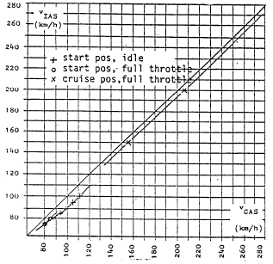

2—5

12

Hoffmann 2
H 36 DIMONA Limitations

2.10 Airspeed Indicator Markings (IAS):

Red Line (Maximum allowable Airspeed)
275 km/h 149 kts 170 mph

Yellow arc (Caution range)
210 — 275 km/h 113 — 149 kts 130 — 170 mph
Green arc (Normal range)
73 — 210 km/h 42 — 113 kts 48 — 130 mph

Yellow Triangle (approach speed)
95 km/h 51 kts 59 mph

Blue Line (Best climb Airspeed)
95 km/h 51 kts 59 mph
CAUTION

Airspeed for the best climb Ratio is:
85 km/h 46 kts 53 mph

2.11 Crew:

Minimum Crew — One Person (min. weight 70 kg = 155 lbs)

CAUTION

Solo flights may be conducted from the left seat only!

2.12 Weights:

Empty Weight: refer to section 6—3, Weighing report
Max. Gross Weight: 770 kg 1698 lbs
Min. Wt. in pilots seat (incl. parachute) 70 kg 135 lbs
Max. Wt. in each seat (incl. parachute) 110 kg 243 lbs
Max. Wt. in baggage compartment 12 kg 27 lbs

CAUTION
Do no overstep the maximum payload stated on p.43

For more detailed loading information refer to section 6, Weight and Balance/Equipment list.

2 - 6
13

Hoffmann 2
H 36 Dimona Limitations

3.13 Center of Gravity Limitations

The Center of Gravity ranges are:

Forward: 270 mm aft of leading edge,
wing root rib

Aft Up to 740kg:
385 mm aft of leading edge,
wing root rib
At 770kg
370 mm aft of leading edge,
wing root rib

Between 740 and 770 kg
linear run between
370 and 385 mm

For more detailed Center of Gravity information refer to section 6, Weight. and Balance/Equipment list.

2—7
14

Hoffmann 2
H 36 DIMONA Limitations

2.14 Placards:

Translation of original placards in German language:

Gepack max 12 kg - Baggage max 12 kg
Storklappen - Radbremse - Airbrake .. . Wheel brake
Vollgas-Gas-Leerlauf - Full - throttle - idle
Brandhahn - Fuel shut off valve
auf ... zu - open - closed
ein . .. aus - on ... off
Luftung - Cabin Air
Heizung - Cabin Heat
Zundung - Ignition
Kraftstoffpumpe - Fuel pump
Hauptsicherung - Main fuse
Kopflastig . .. Trimmung - Nose down .. trim
Schwanzlastig - nose up
Haubennotabwurf - Canopy emergency jettison
Parkbremse .. - Parking brake
Choke - Choke

Text and position of placards in English language:
see following pages.

2—8
15

Hoffmann 2
H 36 DIMONA Limitations
VH-ABC Registration Call Sign in
Centre of Instrument Panel

Canopy Jettison and Emergency Exit  Purl both RED handles on Canopy frame AFT  Push Canopy up and away  Release safety harness  Stand up and exit aircraft from  left or right sides respectively  When using a manual parachute  Release, wait 2 seconds prior to  pulling D—ring. | On lower center console

Airspeed Limits km/h kts mph  Never Exceed VNE 275 149 170  Rough Air Vb 210 113 130  Maneuvering Va 176 95 109  max Gross Weight 770 kg 1698 lbs  min Payload (in pilot seat) 70 kg 154.lbs  max Payload (in any seat) 110 kg 245 lbs  Baggage Maximum 12 kg 26.5 lbs  max Payload see Flight manual page 43 | Below Canopy Frame  Left side

Altitude in ft. 0 - 6500  Vne (KIAS) 149 | 10,000  140 | 13,000  133 | 16,500  126 | 20,000  119 | Below Canopy Frame  Left Side

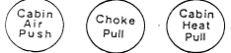 | Labels on operating  Handles Upper Centre  Console

Nose up — Trim — Nose down Next to operating Handle
Next to operating Handle
Parking brake — Pull Air Brake
Lever then move parking brake
lever aft

Baggage Maximum  12 kg 26.5 lbs | In Baggage compartment

2 - 9
16

Hoffmann 2
H 36 DIMONA Limitations

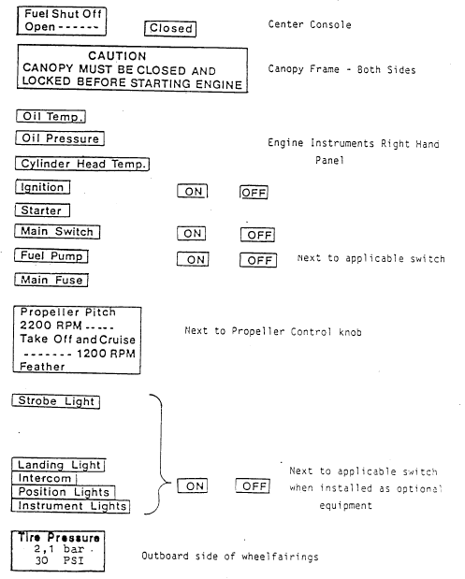

2 - 10
17

Hoffmann 2
H 36 DIMONA Limitations

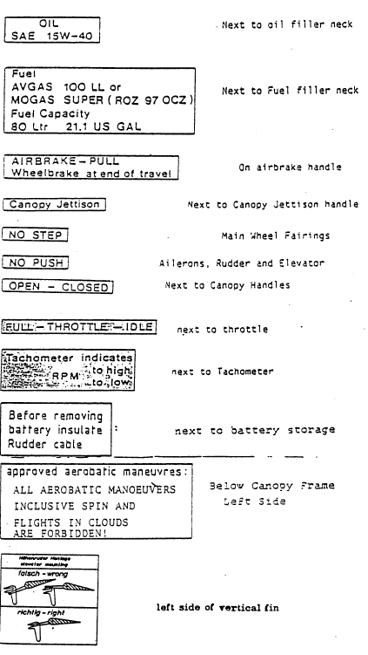
2 - 11

18

Hoffmann 3
H 36 DIMONA Emergency Procedures

Table of Contents

Section 3

EMERGENCY PROCEDURES

Paragraph Page

3.1 Stalls, Power on ---------------------------- 10
3.2 Stalls, Power off ---------------------------- 19
3.3 Spin Recovery ---------------------------- 19
3.4 Engine failure during Take—Off ---------- 20
3.5 Engine failure in flight ------------------- 21
3.6 Emergency Landing ---------------------------- 21
3.7 Icing ---------------------------------------------- 21
3.8 Carburetor Icing ---------------------------- 21
3.9 Water Landings ---------------------------- 21
3.l0 Engine fire during flight ------------------- 22
3.11 Electrical fire during flight ------------------- 22
3.12 Canopy Jettison, Aircraft exiting during flight 22

3-1
19

Hoffmann 3
H 36 DIMONA Emergency Procedures

3.1 Stalls, Power On:

On coming stall warning can be recognized by buffeting on the aircraft and a loss of positive control in the stick and pedals. If permitted to continue, the aircraft will stall and roll over on the stalled wing. A spin may result. When buffeting is encountered relax back pressure on the stick, and if available, add power. Recovery from a clean stall will result in an altitude loss of about 40 meters (130 ft)

3.2 Stalls, Power Off, Prop Feathered:

On coming stall warning is buffeting as with power on, however, the aircraft will not roll on a wing and can be held level with aileron and rudder control. The aircraft will sink vertically at a rate of 700 fpm. Stall recovery in this mode is to relax back pressure on the stick.

3.3 Spin Recovery:

Reduce power and push control stick full forward. Apply fu11 rudder opposite to spin rotation. Recover smoothly from the dive.

CAUTION

The aerodynamic clean form or the DIMONA permits speed to build up rapidly. Vne must not be exceeded. Immediate spin recovery will result in an altitude loss of 280 ft.

C A U T I 0 N

if, under unfavorable circumstances with engine idle a flat spin will result, recover immediately as above but add power.

3—2
20
Hoffmann 3
H 36 DIMONA Emergency Procedures

3.4 Engine Failure during Take-Off:

Check immediately Fuel valve - ON position
Fuel pump - ON position

If these are not the cause of engine failure, and the altitude is less than 300ft, land straight ahead. If more than 300 ft altitude are available, a 180* turn in the glider mode can be made. The propeller should be feathered to reduce drag.

3 - 3
21

Hoffmann 3
H 36 DIMONA Emergency Procedures

3.5. Engine Failure during flight:

Check immediately : Fuel Valve - ON position
Fuel pump - switch ON

If the engine does not start or run, feather prop and establish a glide. Best glide ratio will be accomplished at an airspeed of 105 km/h (57 kts).

3.6 Emergency Landing:

Choose a suitable field while altitude is available. Once you have made your decision, stick to it! Observe wind direction and on final approach position the aircraft to land into the wind. Attempt to land to a point with minimum ground roll. Prior to touchdown, all switches - OFF.

Should engine power still be available, the selected landing site should be surveyed while airborne to see if obstacles exist.

After landing - Throttle - Closed, all switches - OFF.

3.7 Icing

Attempt to leave the icing area as soon as possible.
If necessary, change altitude to escape icing layer.
Continue to move controls to prohibit lockage from ice.
When the canopy is iced over, the weather window may be opened.

3.8 Carburetor Icing

Throttle - FULL POWER.
Attempt to leave icing area as soon as possible, if necessary, change altitude.

3.9 Water Landing:

Stop engine and feather propeller. On final approach jettison canopy. Land with minimum airspeed. On touchdown protect your face with the left arm. After touchdown release seat harness and exit aircraft.

3-4

22

Hoffmann 3
H 36 DIMONA Emergency Procedures

3.10 Engine fire during flight:

Throttle - full power
Fuel Valve - OFF
Cabin Heat - Push ,
Cabin air - Pull
Ignition - OFF when engine Stops
Slipping the aircraft can keep smoke and flames from the cockpit
Execute normal landing from a glide

3. 11 Electrical Fire during flight:

Main Switch - OFF
Circuit breakers - PULL OFF

The engine will continue to run. Land as soon as practical or at the next airfield

3.12 Canopy Jettison - Aircraft exiting during flight:

With engine running - Throttle CLOSED
Ignition OFF

With engine stopped - Prop feathered - Turn prop feather handle to START

Red Canopy locks, left and right - swing AFT

Place both hands above your head against canopy - PUSH

Release safety harness, evacuate the aircraft, left and right When using a manual parachute release, wait two seconds before activating parachute.

3—5
23

Hoffmann 4
H 36 DIMONA Normal Procedures

Table of Contents
Section 4
NORMAL PROCEDURES

Paragraph Page
4.1 Cockpit Layout ............……………… 24—25
4.2 Instrument Console Layout .........………….. 25
4.3 Lower Console Layout ..............…………….. 26
4.4 Preflight Inspection ............... ……………... 26—27
4.5 Preflight Inspection walk around Guide …… 28
4.6 Before starting Engine ............……………... 28
4.7 Starting Engine ...............…………………… 29
4.8 Before Take-Off check ............…………….. 30
4.9 Take-Off and Climb..........…………………. 30
4.10 Cruise ...........………………………………. 31
4.11 Engine Shut-Down and Restart in flight …… 31
4.12 Soaring …………………………………….. 31
4.13 Permitted Aerobatic Maneuvers ....………… 32
4.14 Descent and Approach .........……… 33
4.16 Engine Shut-Down ..…………………….. 33

4—1
4
Hoffmann Normal procedures
H 36 DIMONA
Cockpit Layout

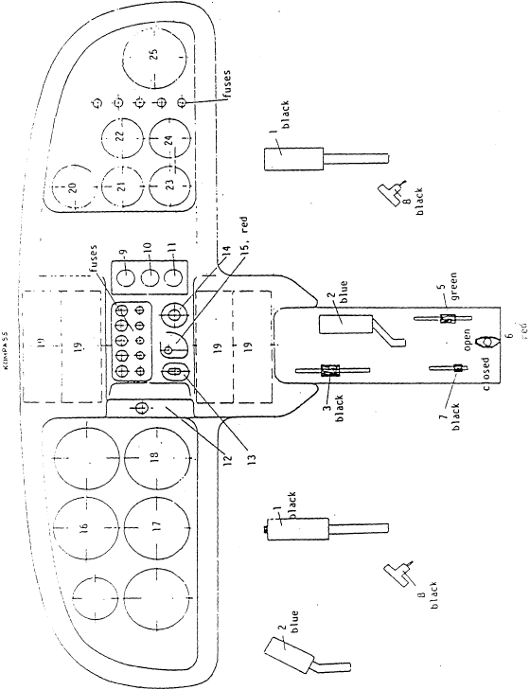

4-2

25

Hoffman 4
H 36 DIMONA Normal Procedures

4.1 Cockpit Layout and Controls Illustration:

1 - stick
2 - airbrake lever
3 - throttle
S - trim
6 - fuel shut off valve
7 - parking brake
8 - Rudder pedal adjustment
9 - cabin air
l0 - cabin heat
11 - choke
12 - Propeller lever
13 - Ignition switch
14 - Starter button
15 - main switch

4.2 Instrument Console Layout:

16. - airspeed indicator
17 - altimeter
18 - climb speed indicator
19 - COM/AVIONIC
2o - cylinder. head temp.
21 - oil temp
22 - oil press
23 - voltmeter
24 - fuel
25 - RPM indicator & hour-meter

4-3

26

Hoffmann 4
H 36 Dimona Normal Procedures

4.3 Lower Console Layout:

2 - airbrake
3 - throttle
5 - trim
6 - fuel shut off valve
7 - parking brake

4.4 Preflight Inspection:

(The areas where these visual checks are to be performed are illustrated in 4.5 “Walk around Guide”).

1. Ignition OFF - Main Switch OFF

2. Open engine cowling - CHECK:
Oil Level
Security of engine controls
Engine and engine parts for security and damage
Foreign objects in engine compartment
Close engine cowling

3. Main Landing Gear - CHECK:
For excessive wear, cuts, abrasions
Wheel fairings for condition and security
Tire Pressure 2.1 bar (30 psi)

4. Right Wing - CHECK
Fibre Glass Skin for damage or cracks Ailerons and push pull tubes for security and condition
Air Brakes and torque tube for security and condition
Wing Tip and position light for security and condition

5. Aft Fuselage - CHECK
Fibre Glass Skin for damage or cracks

4—4
27

Hoffmann 4
H - 36 DIMONA Normal Procedures

6. Elevator and Horizontal Stabilizer - CHECK:
Fiber Glass Skin for damage or cracks
Excessive play in mounting tugs
Mounting tugs safetied?

7. Rudder and Fin - CHECK:
Fiber Glass skin for damage or cracks
Excessive play in mounting tugs
Rudder connected?
Remove Pitot tube covert

8. Tailwheel assembly - CHECK:
Fairing for condition
Tire pressure 2.1 bar (30 psi)

9. Left wing - CHECK:
Perform same check as right wing

10. Fuel Tank Drain - CHECK:
Drain for two seconds. Inspect for dirt or water

11. Cockpit - CHECK:
Wing quick disconnects LOCKED?
Controls for freedom of movement
Required documents

12. Latching hook — CHECK:
Hooks hooked into links and secured ?

4-5

28

Hoffmann 4
H 36 DIMONA Normal Procedures

4.5 Walk around guide:

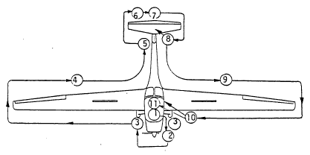

4.6 Before starting engine:

1. Canopy ---- ---- LOCKED
2. Rudder Pedals --------- ADJUSTED
3. Fuel Shutoff Valve -- OPEN
4. Controls --------- FREE
- 5. Airbrake -------- Extend — Retract
6. Parking Brake -------- ON
7. Prop Control ----- MOVE ONE CYCLE
8. Altimeter --------- SET
9. Master Switch ----- ON
10. Fuel Quantity --------- CHECK
11. Baggage ------------- SECURE
12. Seat Harness --------- ON and LOCKED
13. Canopy ------------ RECHECK LOCKED

4—6
29

Hoffmann 4
H 36 DIMONA Normal Procedures

4.7 Starting engine:

1. All Switches except Master --------- OFF
2. Choke ------------------------------------ PULL
3. Throttle ----------------------------------- OPEN ONE INCH
4. Boost Pump ------------------------------ ON
5. Ignition --------------------------------- ON
6. Propeller Area Clear -------------------- CHECK
7. Starter Button --------------------------- PRESS

After engine starts release starter button. Adjust throttle to 1000 RPM. When engine is running smoothly - close the choke.

8. Oil Pressure --------------------------- CHECK
Oil pressure should be in Green Range in 10 seconds
9. Voltmeter --------------------------- CHECK for 14 VDC
10. Radio and Nav. Equipment --------- ON after Engine runs

Allow engine to run for two minutes at 1000 RPM, then increase RPM to 1500 until the oil temperature indicates 50* C. The 1500 RPM phase can take place during taxiing.

4—7

30

Hoffmann 4
H 36 DIMONA Normal Procedures

4.8 Before Take-Off Check:

1. Parking Brake ----------- ON
2. Throttle------------------- OPEN to 2200 RPM
3. Propeller Lever---------- PULL and RELEASE
The propeller should now change to Cruise pitch
4. Throttle ------------------ OPEN --MAX POWER MAX RPM 2300!
5. Throttle --------------- IDLE RPM
6. Propeller Lever --------- PULL AND RELEASE
The propeller should now switch back to Take-Off position
7. Throttle --------------- OPEN --- MAX POWER—— RPM 2700 - 2900

CAUTION

If the RPM setting is not obtained repeat steps 5 and 6. If a take-off is attempted with the propeller in cruise position, a significantly longer take-off roll will result!

4.9 Take—Off and Climb:

1. Parking brake --- release
2. Fuel pump --- on
3. Line up in Position
4. Trim --- SET
5. Throttle FULL POWER (Not less than 2700 RPM)
6. Control Stick --- Light forward pressure, steer with rudder at about 80 km/h
(50 mph). The aircraft will fly itself from the runway.
7. Controls & Trim -—- ADJUST to obtain climb speed of 95 km/h (59 mph) (Blue line)
8. Fuel Pump ——— At 350 feet -——OFF
9. Engine instruments - CHECK

4—8
31

Hoffmann 4
H 36 DIMONA Normal Procedures

4.10 Cruise:

To change propeller position from Take—Off to Cruise the RPM must be between 2000 and 2200. Pull and release the propeller control. A 500 RPM drop should occur without throttle adjustment. The throttle can then be opened for Cruise power (2500 - 3000 RPM) as required.

NOTE
In the cruise mode the throttle can be reduced by 1/3 for fuel economy without a noticeable loss of airspeed.

4.11 Engine Shut-down and Restart in flight:

SHUT-DOWN

1. Throttle -------------------------------- Close to IDLE (for 2 minutes)
2. All electrical equipment not needed ----- OFF
3. Ignition -------------------------------- OFF
4. Propeller control ----------------------- PULL - TURN LEFT

The propeller is now feathered and the wind-milling effect on the engine will cease.

RESTART

1. Choke (with cold engine) -------------- PULL
2. Ignition -------------------------------- ON
3. Propeller Control ----------------------- TURN TO START POSITION

The wind-milling effect should cause the engine to start. Should the speed not produce the wind-milling use the starter to effect RPM.

4. Throttle -------------------------------- IDLE (until oil temperature indicates
500 C) .
To return to cruise flight the propeller control must be again set as in Par. 4.l0.

4.12 Soaring:

When updrafts are encountered reduce power to idle. If positive vertical velocity, shut off engine as in Par. 4.11

Circle climb while maintaining a speed of 90— 95 km/h (56 — 6o mph). To. return to powered flight refer to Par. 4.11.

4—9
32

Hoffmann 4
H 36 DIMONA Normal Procedures

4.13 Permitted Aerobatic Maneuvers:

ALL AEROBATIC MANEUVERS INCLUSIVE SPIN AND FLIGHTS IN CLOUDS ARE FORBIDDEN

4-10
33

Hoffmann 4
H 36 DIMONA Normal Procedures

4.14 Decent and Approach:

Decent with power as required to obtain 180 km/h (112 mph).
When entering pattern the propeller should be switched to START position. When turning base leg reduce power to bring the RPM under 1500 RPM.
On final electric Boost Pump - ON, Airspeed — 95 km ( 60 mph), Yellow Triangle.

4.15 Landing:

Airspeed - Reduce
Airbrakes - as required
Throttle - Closed
Touchdown - Back pressure on stick to produce 3 point attitude

CAUTION

Do not apply full airbrake at touchdown. The coupling with the brake system will result in landing with blocked wheels!

4.16 Engine Shut-Down:

Parking Brake ----------------------- As required
Throttle ------------------------------- Closed (idle engine for 2 minutes for cooling)
Radios and NAV. Equipment ----- Off
Electrical Switches ----------------- Off
Ignition ------------------------------ Off
Master switch ----------------------- Off

CAUTION
If, due to taxiing the brakes have been used excessively, over-heating may result. Do not set the parking brakes until the brakes have cooled.

4-11
33.1

Hoffmann 4
H 36 DIMONA Slip

4.17 Slip:

4.17.1 Entry and Recovery:

Slip is practicable from 80 km/h (43 kt) (50 mph) to 120 km/h (65 kt) (75 mph).

— Throttle idle
— Apply aileron control in direction of intended slip.
— Apply opposite rudder simultaneous.
— To maintain desired airspeed apply aft stick.
— Use airbrakes additionally if required.

Recover:
— Reset controls in neutral position.

4.17.2 Characteristics:
Yaw up to 35* and bank up to 10* are practicable with full rudder and suitable aileron control. High yaw angels require extensive elevator deflections up to the rear stop of the stick.

NOTE
Stall is not possible in the slip. At rear C.G. positions, nose pitches down slowly. Speed after recovery is not less than 80 km/h (43 kt) (50 mph).

Rates of descent from 3 m/s (600 ft/mm) to 8 m/s (1600 ft/mm) are attainable dependent on airspeed and yaw.

4—1 2

33.2

Hoffmann 4
H 36 DIMONA Slip

4.17.2 Characteristics cont.:

At low airspeeds and high yaw angels rudder control force reversal may occur. Recover force does not exceed 20 N (4 pounds). If aileron control is reset to neutral, rudder returns to neutral without assistance.

NOTE
Bank angels above 10* cause a turn in slip direction. Airspeeds above 120 km/h (65 kt) (75 mph) cause the same effect.

CAUTION
Due to high rates of descent recover from slip at least 20 m (60 ft) above ground level

4.17.3 Indicated Airspeed Errors:

At yaw angels below 25* indicated airspeed error does not exceed 12% of CAS.

At higher yaw angels airspeed indication is no longer interpretable due to wing wake on the pitot static tube.

4—13
34

Hoffmann 5
H 36 DIMONA Performance Data

Table of Contents
Section 5
PERFORMANCE DATA

Paragraph Page
5.1 Take—Off Distances 35
5.2 Landing Distances 36
5~3 Rate of Climb 36
5.4 Cruise Speed 36
5.5 Range 36
5.6 Fuel Consumption 36
5.7 Maximum Altitude 37

5—1
35

Hoffmann 5
H 36 DIMONA Performance Data

5.1 Take—Off Distance:

All figures are based on ICAO standard atmosphere, Gross Weight of 770 kg (1698 lbs).
Airfield conditions: calm wind, dry flat surface with short grass.

Take-Off speed: 80 km/h IAS (50 mph)
Climb speed: 85 km/h IAS (53 mph)

Field Outside Air Temp. C
Elev. -15 0 +15 +30
Take-off roll until lift off | (mtr)  0 | (ft)  0 | m 185  ft 607 | 196  643 | 207  679 | 218  715
 | 250 | 810 | m 191  ft 267 | 202  663 | 213  699 | 224  735
 | 500 | 1625 | m 197  ft 646 | 208  682 | 220  722 | 231  758
 | 750 | 2438 | m 203  ft 666 | 215  705 | 227  745 | 238  781
 | 1000 | 3250 | m 299  ft 686 | 221  725 | 234  768 | 246  807
Take-off distance to | 0 | 0 | m 305  ft 1001 | 333  1043 | 361  1184 | 389  1276
Clear 15 mtr (50 ft)  obstacle | 250 | 810 | m 320  ft 1050 | 348  1142 | 375  1230 | 403  1322
Clear 15 mtr (50 ft)  obstacle | 500 | 1625 | m 334  ft 1096 | 362  1188 | 391  1283 | 419  1375
Clear 15 mtr (50 ft)  obstacle | 750 | 2438 | m 349  ft 1145 | 378  1240 | 406  1322 | 434  1424
Clear 15 mtr (50 ft)  obstacle | 1000 | 3250 | m 363  ft 1191 | 394  1293 | 426  1398 | 457  1449

5—2
36

Hoffmann 5
H 36 DIMONA Performance Data

5.2 Landing Distances:

All figures are based on ICAO atmosphere, Gross Weight of 770 kg ( 1698 lbs).
Airfield conditions: Calm wind, dry, flat surface, with short grass.

Approach speed - 95 km/h (60 mph) Yellow Triangle Marking
Touchdown speed - 70-75 km/h (44 -46 mph)

Landing Roll - 198 mtr (643 ft)
Landing Distance (over 50 ft obstacle) 378 mtr (1,228 ft)

5.3 Rate of Climb:

Rate of climb, propeller in START position
95 km/h (60 mph) IAS 2.8 m/s 532 fpm

Rate of climb, propeller in CRUISE position
120 km/h (75 mph) IAS 2.0 m/s 394 fpm

5.4 Cruise speed:

At maximum continuous RPM (3000 RPM)

Straight and Level Flight - 190 km/h (118 mph)

5.5 Range:

At a cruise speed of 180 km/h the range is 960 km (with no reserve).
Wind factor is not considered.

At a cruise speed of 150 km/h at an altitude of 1,500 mtr (5000 ft) the range is 1000 km (with no reserve).
Wind factor is not considered.

5.6 Fuel Consumption:

At an altitude of 1,500 m (5.000 ft) the fuel consumption is:
150 km/h — 12 1/h (3.16 US Gal)
180 km/h — 15 1/h (3.95 US Gal)

CAUTION
The fuel quantity indicator has an error factor of + 10 %. Take-Off with less than 1/4 tank indication is prohibited!

5—3
37

Hoffmann 5
H 36 DIMONA Performance Data

5.7 Maximum Altitude:

Aircraft weight; 770 kg, ICAO standard atmosphere.

The DIMONA has demonstrated the ability to climb to5,500 m NN (18,045ft).

5—4
38

Hoffmann 6
H 36 DIMONA Weight & Balance Equipment list
Table of contents
Section 6
WEIGHT AND BALANCE
EQUIPMENT LIST

Paragraphs: Page
6.1 Empty Weight ---------------------------------------------- 39
6.2 Reference Datum Line and CG Limits ------------------- 39 — 42
6.3 Weight Report ---------------------------------------------- 43
6.4 Minimum Equipment List (incl. in fleet weight) --------- 44
6.5 Additional Equipment list ------------------------------------- 44

6—1
39
6
Hoffmann Weight & Balance
H 36 DIMONA Equipment list

6.1 Empty Weight:

The DIMONA is weighed at the factory after the minimum equipment and extra accessories have been installed. The weight and the empty weight CG is entered upon the weight report found in Par. 6.3. Should, at some time the aircraft be repaired, or additional equipment added, the aircraft should be reweighed to adjust the weight report accordingly. After removing or adding equipment a sample weight & balance problem should always be performed to insure the CG limits have not been exceeded.

6.2 Reference Datum Line (RDL) and CG Limits:

The reference datum line (RDL) is the leading edge of the wing at the wing root rib. The aircraft leveling point is the underside of the wing, mid chord.. The CG Limits are measured in mm from the RDL aft.

Forward CG Limit: 270 mm
Aft CG Limit
— Up to 740 kg: 385 mm
— At 770 kg: 370 mm
Between 740 and 770 kg linear run between 385 and 370 mm.

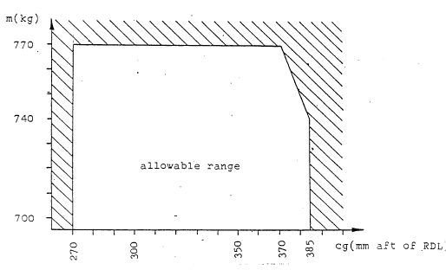

6—2
40
6
Hoffman Weight & Balance
H 36 Dimona Equipment list

Sample Problem: Pilot 80 kg, Co-Pilot l00 kg,
Baggage l0 kg, Empty Weight 520kg
Empty Weight CG 340 mm, Fuel 80ltr/57,6kg
_____________________________________________________________
Arm Weight Moment
(mm) (kg) (kg/mm).
Empty Weight 340 520 176.800
1. Pilot 143 80 11.440
2. Pilot 143 100 14.300
Baggage 834 10 8.340
Fuel 834 57.6 48.038
767.6 258.918

The result of the above problem places the CG at 337.3 mm which is within the allowable range. An additional problem may be calculated, for example, that all the fuel is consumed and the aircraft will continue to fly and land as a glider. By removing the 57.6 kg of fuel and the moment, the resultant CG will be 297 mm, still within the allowable CG range.

6—3
41
Hoffmann Weight & Balance 6
36 DIMONA Equipment list

6.2. cont.

Empty weight CG limits:

With a min. weight of 70 kg (155 lbs) in pilot’s seat, the CG will be within the allowable range, if the empty weight CG is within the limits shown below:

Empty weight CG
(mm aft of RDL)

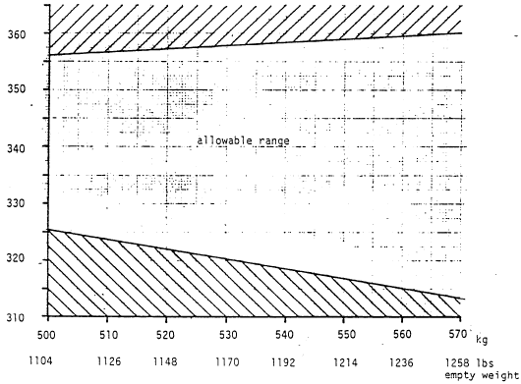

6—4
42
Hoffmann Weight & Balance 6
H 36 DIMONA Equipment list

6.2. cont

Determination of empty weight CG position:

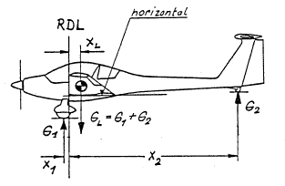

Put x₁ and x₂ with their absolute value in mm into the formula

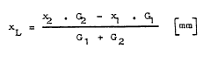

where:

X L is the empty weight CG position in mm aft of RDL (reference datum line).

6—5

43
6
Hoffmann weight & Balance
H 36 DIMONA Equipment List

6.3
Weighing Report:

Date of weighing carried out by: | Equipment first used for weigh (date) | Empty weight kg (lbs) | Empty C of G (behind datum) mm/in. | Empty weight moment | Max. Payload kg (lbs) | Sign

The empty weight momentum is necessary to calculate the CG for flight (load table)

6—6
44
6
Hoffmann Weight & Balance
H 36 DIMONA Equipment List

6.4 Minimum equipment List:

The minimum installed equipment, installed at the factory consists of the following:

1. Airspeed indicator
2. Altimeter
3. RPM indicator with hour-meter
4. Oil Pressure Indicator
5. Oil Temperature Indicator
6. Cylinder Head Temperature Gauge
7. Fuel Quantity Indicator
8. Voltmeter
9. Standby Compass
10. Two seats, restraint harness
11. Loading Plan
12. Data Plate
13. Flight Handbook

6.5 Additional Equipment List:

Item | Arm (mm) | weight (kg) | Moment (kg/mm)
1.
2.
3.
4.
5.
6.
7.
8.
9.
l0.
11.

.

6—7
45

7
Hoffmann Systems Description
H 36 DIMONA

SECTION 7

7.1 Cockpit Description:

1. Instrument board:

Is in three sections, the flight instruments are on the left, engine’ instruments on the right, and tilted for better viewing. The center console is for the installation of COM and NAV equipment. The main switch ON position is down and OFF when turned to the right.

2. Control Stick:

One stick for each seat, with built-in microphone switch.

3. Air Brakes:

The airbrake levers are colored blue and are on the left cockpit side and the middle console. The levers have no down lock due to spring loading.

4. Rudder Pedals:

Two seats, left and right. Pulling the adjusting handle forward of the control stick, and pushing with the feet against the pedals permits forward adjustment. To move pedals aft, pull handle and let pedals snap into the desired rear position.

5. Cockpit Heat:

Pulling the knob permits heat entry thru the cabin heat duct.

6. Choke:

The choke knob closes butterfly valves in both carburetors thru cables. It must not be used to shut down the engine, and under no circumstances should a takeoff be attempted when the choke knob is activated!

7. Throttle Lever:

The throttle lever is on the lower middle console next to the Air Brake Lever. Full throttle = Lever full forward.

8. Trim:

The trim lever (coloured green) is behind the throttle on the middle lower console. To effect trim move lever to the left to clear locking lugs and move in desired trim direction, i.e. lever forward — nose down, lever aft — nose up.
7—1

46
Hoffmann. 7
H 36 DIMONA System Description

8. Parking Brake:

Is located next to the trim lever on the lower middle console. To engage parking brakes pull firmly on the air brake lever, and move then park brake lever aft. Release air brake lever. To release the park brake, again pull firmly on the air brake lever and move the park brake lever forward. Pulling on the airbrake lever alone will not engage or disengage the brakes, and will damage the partening brake mechanism!

9. Canopy Lock:

Are red levers located left and right on the canopy frame. To close the canopy push shut with the black grips located on the canopy frame, then turn the red levers to lock the canopy. To open the canopy reverse the sequence.

10. Emergency jettison:

The red levers are located left and right on the canopy frame. use review Emergency Procedures, Par. 3.12.

11. Propeller Control:

The propeller control lever is on the upper middle console. For use review Normal Operations, Par. 4.8.

12 Fuel Shut-Off:

Located on the lower rear, middle console. The valve is open when positioned to line of flight (fore and aft)

13. Seat Adjustment (special equipment)

To adjust for height, pull seat up and reset in lugs to the desired height. To adjust for tilt, seatback pulled forward, and reset the horizontal tube in the desired Lugs. Push seat back to original position.

7—2
47
Hoffmann 8
H 36 DIMONA Aircraft Handling
and Servicing

Table of Contents
Section 8
AIRCRAFT HANDLING
AND SERVICING

Paragraph Page
8.1 Aircraft Assembly 48 — 49
8.2 Aircraft Disassembly 50
8.3 Transporting the Aircraft 50
8.4 Storage 51
8.5 Cleaning the Aircraft 51

8—1
48
Hoffmann 8
H 36 DIMONA Aircraft Handling
and Servicing

8.1 AIRCRAFT ASSEMBLY:

1
Inspect all bolts and bushings for condition and apply a light coat of grease.

- WINGS -
2.
Move the trim lever to full NOSE DOWN position Open latching — hooks.

3.
Place the mounting lever on the mounting lug, located in the rear middle console

4.
Unhook the wing (either wing) from its hanging mount. By holding it by the wing tip pull the wing outboard on its carrying tube

5.
Then walk forward until the wing is 90* from line of flight

6.
Rotate the wing until the root ribs are parallel and push wing into fuselage. An assistant at the wing trailing edge should observe the smooth insertion of the two shear bolts. Let latching-hooks snap into links !

7.
Move the wing tip up and down lightly while the assistant locks the main mounting bolt by pushing up on the mounting lever. The aileron and airbrake drive units are automatically hooked up.

8.
Install the other wing in a similar manner. The wide tread of the DIMONA landing gear allow the mounted wing to support itself and it requires no outside support.

8—2
49
Hoffmann 8
H 36 DIMONA Aircraft Handling
and Servicing

9.
After both wings have been mounted remove the mounting lever and install the safety clip in the main mounting bolts.

- HORIZONTAL FIN & ELEVATOR-

1.
Position Fin above Vertical Fin

2.
Raise Elevator slightly and firmly, push fin aft against the stop

3.
As you push the fin aft guide the elevator drive fork into the elevator lug

4.
Lock safety pin

- FINAL ASSEMBLY -

1.
Plug in compensation nozzle - if desired

2.
Apply tape, if desired to gap between wing and fuselage

CAUTION

Check elevator control for proper connection and inspect elevator actuator inserted in driving fork

8—3
50
Hoffmann 8
H 36 DIMONA Aircraft Handling
and Servicing

8.2 AIRCRAFT DISASSEMBLY:

1.
Aircraft dis assembly is performed by reversing the steps outlined in 8.1

8.3 TRANSPORTING THE AIRCRAFT:

1.
For road transportation a closed trailer should be used. The components should be cushioned and protected against slippage or free movement. Chocks for all three wheels are excellent for this purpose.

2.
The fuselage is transportable on the main gear and tail wheel. The fuselage unit should be tied down or blocked to prevent fore and aft and vertical movement. The propeller should be checked to insure enough clearance in the trailer.

3.
The wings do not have to be removed for road transportation The wing remains attached to the fuselage by the telescopic-tube. When folded, the wing should be cushioned by a 400 mm wide profile cushion under the butt rib. This will prevent the telescopic tube from damage. An additional profile cushion should be placed about 4 in (13 ft) outboard of the butt rib. The cushion should be at least 300 mm (14 in) high.

The wing should be tied down to prevent rearward movement. The rear shear bolt on the fuselage should be padded to prevent damage to the wing skin.

The horizontal fin and elevator can be placed in the trailer flat or vertically. The retaining straps or profile cushions must be cushioned or padded to prevent damage to the unit.

8—4
51
Hoffmann 8
H 36 DIMONA Aircraft Handling
and Servicing

8.4 STORAGE:

For hangar storage the wings can be folded as in Par. 8.2. The wing tips can be hung from the horizontal fin with the provided support fixtures. The rear shear bolts on the fuselage should be padded to protect the wing skin.

Should the aircraft be placed in extended s 3rage, it is recommended that profile cushions be placed under the wing as in Par. 8.3.3.

The storage room or hangar should have good air circulation in order to preclude moisture build-up.

8.5 CLEANING THE AIRCRAFT:

The entire surface of the DIMONA is painted with a weather proof two component paint. Regardless, the aircraft should be protected against excessive moisture or dampness. The aircraft should not be placed in open or unprotected storage for long periods of time.

Dirt, insects etc. can be removed by washing, using warm water and a mild detergent.
For stubborn spots an automotive paint cleaner can be used.
For best result the aircraft should be cleaned after the day’s flying is ended.

The lower fuselage surfaces should be inspected for oil and exhaust stains. These can be removed with a cloth moistened with Stoddard solvent or dry cleaning fluid. The areas where oil is present, i.e. breather tubes should be inspected to insure that the oil has not damaged the paint finish.

Polishing the aircraft can be done by using a good quality automotive wax. The Plexiglas canopy should be washed with warm water and a mild detergent. Final cleaning is done with a chamois or a soft cotton cloth. Do not rub or polish dry plastic!

Several good anti-static plastic cleaners are available at Aviation Supply Houses, and can be used.

8—5
52
9
Hoffmann Supplements
H 36 DIMONA

Table of Contents
Section 9
SUPPLEMENTS

Paragraph: Page

9—1

